

Contents
1 Analysis 3
1.1 Introduction 3
1.2 Background 3
1.3 Research 4
1.3.1 User 5
1.3.2 Similar Applications 9
1.3.3 Technical Challenges 10
1.3.4 Conclusion 12
1.4 Modelling 13
1.4.1 Front End 13
1.4.2 Back End 14
1.4.3 Database 14
1.5 Objectives 14
2 Design 17
2.1 Description 17
2.2 Interface Design 18
2.2.1 Explanation 18
2.3 Top-Down Diagram 19
2.4 Algorithms & Code 20
2.4.1 A* Algorithm 20
2.4.2 Pre-Processing of Data 22
2.4.3 Filter Node Selection 23
2.4.4 Create Speed and Neighbour Grids 25
2.4.5 Node Class 27
2.4.6 Database Design 27
2.4.7 Data Initialisation 29
2.4.8 Heuristics 30
2.4.9 Directions 31
31
2.5 Technical Solution 32
2.6 Interface Screenshots 57
2.7 Techniques Used 59
3 Testing 61
3.1 Tests 61
3.2 Objectives Met 68
3.3 Conclusion 69
3.4 User Feedback 70
3.5 Improvements 71
3.5.1 Interface 71
3.5.2 Route 71
3.5.3 Route Capabilities 71

Analysis

Introduction
The name of the project I have decided on for my NEA is ‘Shortest Route Navigation App’. This will be a web application designed to help users to find the most efficient route between two locations. My intended user will be daily commuters, as well as delivery drivers who will both want the most efficient routes to reach their destination.

Background
Algorithms are a major component of the Computer Science course, where pathfinding is a fundamental concept leveraged to develop a clear understanding. Pathfinding is an integral algorithm, especially due to its many applications within many different fields.
Path finding is becoming more prevalent in videogames, especially with Non-Player-Character (NPC) navigation. Pathfinding allows for these NPCs to move more intelligently and navigate around obstacles by utilising these algorithms. Path finding algorithms are heavily relied on in Maze and puzzle solving games. These games often use algorithms to compute a path on procedurally generated maps
These algorithms are also used within robotics applications and drones. Especially with the constantly evolving world of AI, robots can use these algorithms for autonomous navigation, like those in self-driving cars, planning routes beforehand using real world environmental variables. Factories and Warehouses use them for motion planning in robotic arms; A notable example of this is within Amazon’s warehouses, where these robots are crucial for managing their deliveries and stock.
Pathfinding is widely utilised in Navigation Applications, where time efficiency and route optimisation are vital. These algorithms help optimise the routes for drivers to take to reach their destination as quick as possible. This is very important within logistics and emergency services where time is a deciding factor; delays can greatly affect outcomes and be very financially unsustainable for businesses.
When navigating through busy towns with many roads, it may be confusing for drivers, especially those unfamiliar with the area. This can result in drivers taking more frequent stops and have a higher chance of making wrong turns. This can result in the amount of travel time increasing as well as the routes taken becoming much less efficient. To solve this problem, I aim to create a route-finding application that will be able to filter out the roads with the shortest distance and/or the shortest time to travel between two given points. I will then display this data in a clear format for the user to interpret. This will make it a lot simpler for drivers to navigation through unknown areas, making travelling more intuitive and efficient. To complete this, I will need to engage in extensive research to ensure I am well informed with all the different methods and algorithms available to complete this project.

Research
The first part of my extensive research will include deep research onto all the algorithms available for me to complete this task. I will compare between 5 of the most efficient and common algorithms and use this as a basis on my decision.
The A* Algorithm is a popular pathfinding method used to find the shortest distance between two points. It is widely used in GPS systems and robotics to help navigate around obstacles and is designed to traverse weighted graphs. This works by combining the actual travel distance with an estimate of the remaining distance to quickly find the best path. Heuristic’s can be provided to further optimise this algorithm to ensure the most efficient search.
Dijkstra’s algorithm is used to find the shortest path between two points by exploring paths systematically in an increasing order of distance. It stores the shortest known route to each point and updates it accordingly until the destination is reached. This does not utilise any heuristics and is often used when a simple, reliable search algorithm is required. However, when navigating larger graphs, it can be a lot slower. Due to not utilising any heuristics, it navigates all possible paths in order, therefore if the network large the time to find the path may increase.
Bidirectional pathfinding finds the shortest path by searching simultaneously from both the start and end points at the same time, meeting in the middle. This approach reduces the search area and speeds up finding the path. This algorithm can be used with or without heuristics, depending on the implementation. However, due to managing two searches at once, the memory usage can be more intense, therefore performing less efficiently on low end hardware.
Breadth-first search is a simple algorithm that finds the shortest path by exploring nodes in layers, from the source and visiting all neighbouring nodes before moving further out. It does not use any heuristics or estimates, and rather systematically checks every possible path. It is often utilised in applications where finding the shortest path without weights is needed.
Depth-first search is an algorithm that searches through tree or data structures. It starts at a root node and explores as far as possible along each branch before backtracking. Like Breadth-first search, DFS does not use any heuristics, instead following a strict path-based strategy. It is often utilised in unweighted algorithms, such as mazes. However, it does not evaluate the ‘best’ path (shortest) and rather just finds the first path to its destination. Due to this, it will not be applicable for my project.
This table below will highlight the Time Complexity, Space Complexity and whether it finds the most optimal route, that being the shortest.
Algorithm | Time Complexity | Space Complexity | Heuristic Used? | Optimal?
A* | O((V + E) * log V) | O(V) | ✓ | ✓
Dijkstra’s | O((V + E) * log V) | O(V) | ✕ | ✓
Bidirectional | (O(b^(d/2)) | O(b^(d/2)) | ✓/✕ | ✓
BFS | O(V+E) | O(V) | ✕ | ✕
DFS | O(V + E) | O(V) | ✕ | ✕
V – Vertices/Nodes, E – Edges, b – Branching Factor, d – Depth
The following sections will summarise the additional research that I have undergone to gain an insight on how I plan to solve this problem and how I will progress further. I have split my research into the following 3 key areas:
- User – I have discussed my idea with potential users to find out what features are most important to them and what will benefit them the most.
- Similar Applications – There are many applications available that all work similarly to my intended project, and I have summarised my findings below.
- Technical Challenges – Along with this project come some ideas that may be a challenge for me to implement. In this section, I will delve deeper into these features and where I will consider the time constraints and how they may influence my decisions.
Each of these areas are discussed below in detail.

User
To gather users’ perspective, I have utilised many forms of data gathering, including online forms, as well as direct dialogue with users.

Online Forms
For my project I wanted to ensure I had the opinions of as many people as possible, all from different backgrounds. To do this, I have utilised the free forms utility, ‘Google Forms’ to create and distribute a form for potential users to fill out. I have created the form with a direct focus on the features that users look for on navigation apps. I have kept the form very concise, taking no longer than 5 minutes to complete, to ensure as many people can find the time to submit answers.
A link to the form I have created
I have posted this form onto several different forums to maximise the potential responses to my form.
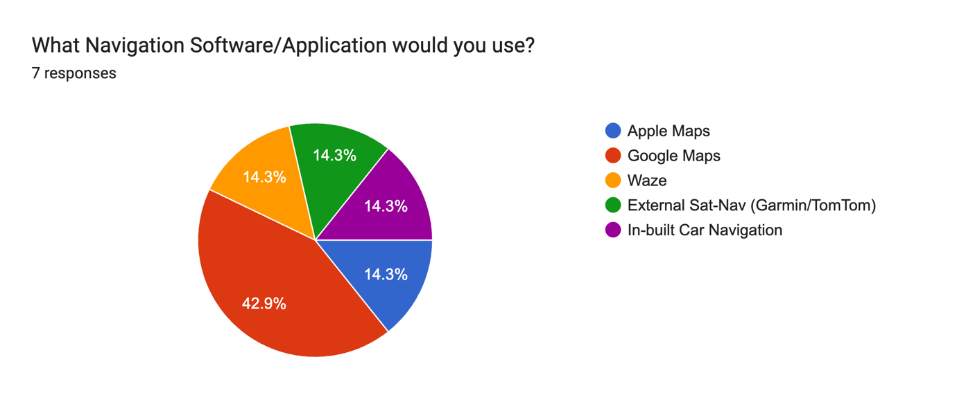

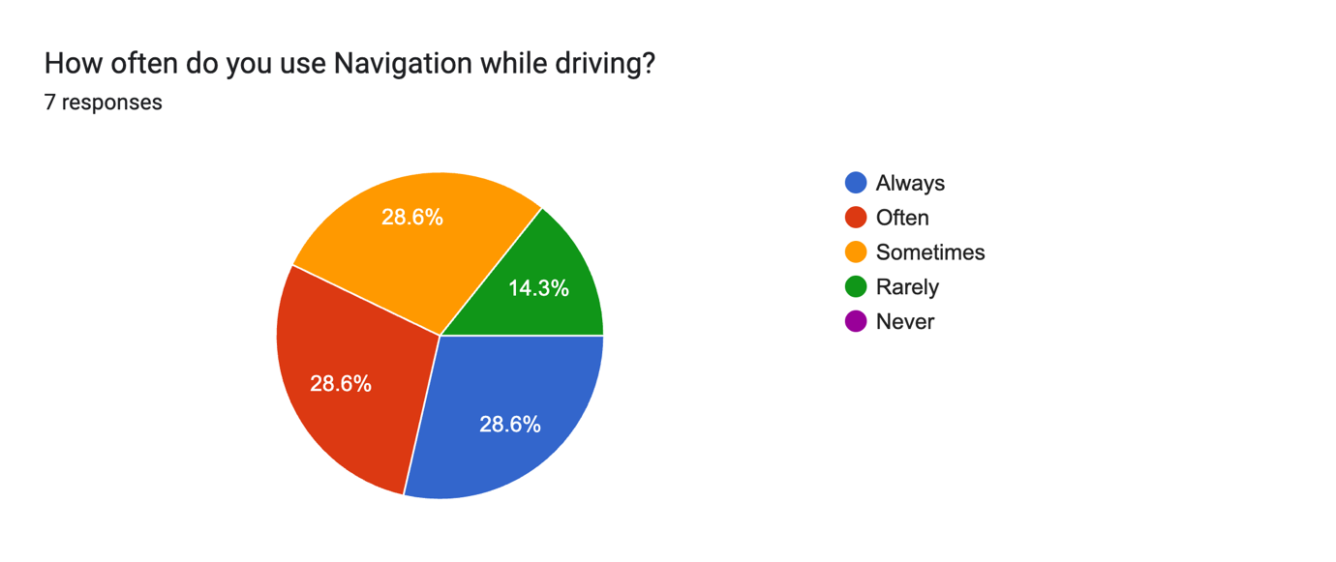
A majority of the users I have sent this survey to have stated Google Maps as their main navigation software choice. Because of this, I will spend more time researching google Maps and what they implement into their service that make it favourable to drivers. The main textual reasoning I have found to why users prefer Google Maps is because of its ease of use. This highlights to me that users care more about the experience using the app rather that all the cool new features that may be added. I know I need to spend more time focusing on the fundamentals of the application rather than anything additional.
I can also identify that all of these users have had to rely on navigation apps at some point in time. This highlights the importance of it, and why I have decided on this as my project. I intend to solve the main problems people face with navigation and provide a lightweight, functional app that anyone can use.
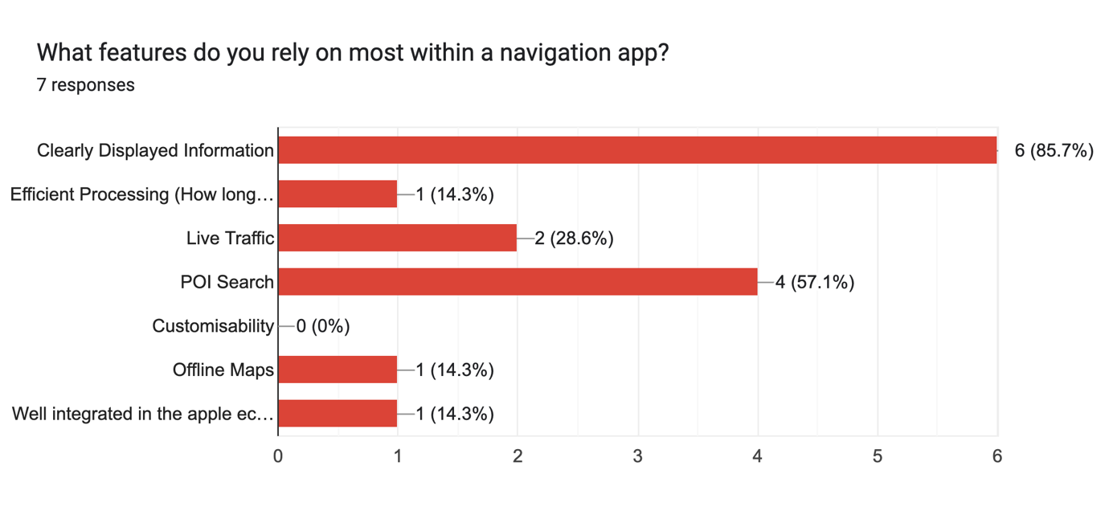
Clearly displayed information has beat every other option on this table by a large amount, again further proving my point about how users care more for ease of use and functionality rather than brand new features. This highlights its importance and shows that I need to focus on this within my Design.

Direct Dialogue
To gather more descriptive data, I have decided to have a direct dialogue with a person from within my network. This will allow me to get a deeper insight and understanding to the background behind why different answers may have been chosen. The person I have chosen to converse with is Duncan Fischer, an Executive Client Accounts Manager working out of Central London.
Duncan’s weekly commute to work is often very unreliable; the same route he travelled one day may not be a viable option to travel another day. This is all due to a wide variety of factors, including congestion, roadworks, and general city driving. Because of this, he regularly utilises navigation to ensure his arrival to work on time. Furthermore, when Duncan goes to visit family, he must take a multiple hour drive out of the city where he would also require navigation. Because of this, I believe he is a perfect target user for my questions.
Me: Hi Duncan, thanks for finding the time to talk. First off, can you tell me little a bit about your commute and how often you use navigation apps?

Duncan: Yeah, no worries. Honestly, I use navigation a lot, especially with London traffic. Even though I know my way around London and have a route I follow, it changes all the time because of traffic. One day it’s fine, next day there’s roadworks or some random closure. So yeah, I’d say I use it pretty much every time I step foot into my car

Me: What navigation apps do you use the most, and why do you prefer them?

Duncan: I mainly use Google Maps. Sometimes I’ll switch to Waze if I know traffic’s going to be bad. I like Google Maps because it’s straightforward and it has reliable arrival times. Waze is good for real-time stuff, if there is an accident or police ahead its usually first to know.

Me: What features do you look for in a navigation app?

Duncan: Live traffic updates are a big one. I need accurate arrival times. If it says I’ll be there at 8:45, I need that to be realistic, especially with commuting to work. Rerouting is also important. If traffic builds up, I want it to change to a quicker route without any input from me. Also, clear voice directions are super useful. I don’t want to be staring at my phone while driving through Central London. That’s an easy way to get into a crash.

Me: How important is reliability when it comes to navigation for you?

Duncan: Massive. If it sends me down a route that’s suddenly blocked or gridlocked, that’s frustrating. In London especially, one wrong turn can add 20 minutes easy. Mistakes like this can mean I’m late to work. I need something that adapts quickly.

Me: You mentioned longer drives out of the city to visit family. How does your navigation use change for those trips?

Duncan: For those, I rely on it the whole way. That’s a few hours’ drive, so I’ll have it running start to finish. It’s more about avoiding roads that suddenly clog up or getting warned about delays early so I can adjust. Out of the city all navigation apps tend to be more reliable, probably because traffic isn’t as volatile as within the city.

Me: What don’t you like about most navigation apps?

Duncan: Sometimes they overreact and reroute you constantly and it just gets confusing. Also, battery drain can be a pain. I have the newest phone and sometimes when I leave it unplugged, I still lose half of my battery.

Me: If you could improve one thing about navigation apps, what would it be?

Duncan: I’d make them more lightweight, to be honest. Lots of these apps are heavy, and have background stuff running, draining battery and using data. I don’t always need all the extra features, just solid directions and reliable live traffic. Something efficient would be helpful, especially since I am relying on it almost every day.

Me: Thanks Duncan, that’s really helpful.

Duncan: No problem, anything that makes London traffic less painful sounds good to me!

From this dialogue with Duncan, I have found that his most favoured features are Live Traffic and Smart Re-routing. I understand how this is important to Duncan, especially living in a city which is constantly gridlocked. Routes can be very unreliable, and rerouting is probably a daily occurrence. Furthermore, he focused on how a lot of navigation apps are ‘heavy’ with many additional features and processes that make it more performance intensive. Given Duncan’s daily use of the navigation, he simply requires an app to generate a route while being as lightweight as possible. This is one of my goals, as keeping my solution lightweight ensures it can be ran on as many devices as possible.

Similar Applications
I have spent some time researching and using apps with a similar functionality to my project. I have gathered information on what different features they have and what I like about each. Below, I have researched 3 of the most popular navigation apps available.


Google Maps
Google Maps was first developed in Australia at ‘Where 2 Technologies’ in October 2004, before being acquired by Google, who converted it into a web mapping platform.
Google has a wide range of features, with its functionality spanning further than just map navigation. Google Maps has frequently been first to introduce innovative new ideas, such as Streetview, making it my personal favourite out of all the apps I have researched. However, regarding the project I am currently undergoing, I will only focus on features linked with mapping and navigation.
One feature I have taken interest in is Google Maps’ implementation of Traffic Information. This takes real time data on nearby accidents and congested roads and uses it as an additional factor when calculating faster routes. This is important as especially in denser areas, delays can be more frequent. It can allow for the planning of routes beforehand, as traditionally ‘quicker’ routes may not be as quick as to detour and avoid traffic. Considering my project is about creating an app that finds the quickest route, this will be extremely helpful to ensure the route is as short as possible.
Another Feature I like is its search feature. This is important for resolving destination and start points for the route. It avoids the need for the user to be extremely precise when inputting addresses, which increases the how intuitive the interface is. This can be replicated through geocoding, which is offered by a wide range of API’s

Apple Maps

Apple Maps was founded in 2012 as a proprietary app on Apple iPhone devices, replacing Google Maps as it’s default navigation application
I really like the user interface of this app, and how easy it is to navigate. Furthermore, the implementation of the app within the iOS operating system is seamless and makes it extremely smooth and efficient to use.
One feature I like is the ‘Nearby’ Feature. This utilises the device’s geolocation to highlight all the closest landmarks when provided a filter to search through. This could increase the efficiency of the search algorithms as it can search by distance as well as the address provided.
I also like the clearly highlighted Congestion Zones. In many major cities, a toll has been added onto cars that drive through central cities at certain times of the day. This is with the aim to limit traffic and make it easier to navigate. However, many drivers may want to avoid this expense while still reaching their destination. When finding routes through these cities, the App provides an option to either avoid or use ‘toll-roads’ (including congestion zone).


Waze
Waze was founded in 2006 by an Israeli Company aiming to improve navigation by crowdsourcing data from its users. It combines Waze with a social-media type system where users can share information about potential traffic and speed cameras, effectively reducing congestion, sometimes quicker than competitors.
One feature implemented by Waze that I like is real time rerouting. Often on journeys, unexpected accidents or traffic congestion can occur. To circumvent this, Waze will check the route ahead and take a detour if required. This can help save the driver time on their journey and ensure that the route being taken is always the quickest route possible
Another feature I like is its extensive customisation ability. In the app settings, you can change the icon used during navigation to a wide range of cars (Formula One, Convertible, etc), as well as providing custom voices to dictate the journey. This adds a level of personalisation with the app as drivers can customise it to their liking. While this is not directly linked with route finding, this can still be a cool feature to implement.

Technical Challenges
While completing my project, it will be inevitable that I will run into systems and/or ideas that may be hard to implement. Because of this, it is important that I foreshadow what these problems may potentially be to ensure that I am prepared to tackle these problems and have the relevant knowledge to judge whether each project is timebound

Live Traffic Information
As part of my research, I have concluded that a large majority of my target audience value live and accurate traffic information that may impede their journey. Out of all the features from the navigation apps I have researched, I have regularly seen this implemented. This is one of the most important features for my project as traffic can have the greatest impact on travel time.
From my research, I have found a few API’s that can help me add these features. I have narrowed this down to two API’s, ‘Here Maps’ and ‘TomTom Live Traffic’. TomTom and Here Maps are some of the largest providers of map navigation and have an extensive network of devices and cars that utilise their software. Due to their large market, they can anonymously track the positions of cars and map where there may be more congestion. This provides accurate information on traffic and allows for navigation to quickly reroute if a quicker route is found avoiding traffic. Both companies offer a generous amount of API uses which is perfect for my use scenario as it allows me to test my implementations and showcase my project without having to spend any of my own money.

Geolocation Tracking
Traditional Navigation Apps provide real time location tracking as the driver follows the set route. This is also a feature commonly seen in other navigation apps and is essential for drivers to follow their route. This makes the route a lot clearer, highlighting each turn in the course, allowing for minimal chance of missing turns especially on longer drives.
There are several features that can be used to implement this native to programming languages, without requiring any external libraries. As I plan to create a web application, I can utilise JavaScript and its built-in libraries to retrieve geolocation data of users to map their location to their route. However, geolocation data alone will not implement this feature fully; I will still need to provide real-time updates of the user’s location, as well as adding rerouting features in case the driver takes a wrong turn. This makes the total difficulty of implementing this project a lot more severe, as it will take a greater amount of my time to add, and may not fit within my strict project time schedule. Due to this, I will attempt to add this feature at the end of my project with any extra time I may find to make sure I don’t overpass my deadline.

Geocoding
Geocoding is where addresses get turned into more computable data. Computers need a universal, precise, and compact way to represent any point on earth. This format has been agreed to be values for latitude and longitude. Unlike addresses, which vary from format and language, these measurements are consistent and work well for calculations, especially with measuring distance and mapping locations.
Despite being simple for computers to understand, it is not very legible for humans. This is where reverse geocoding can be utilised. This is the process of converting these geographic coordinates into a human-readable address. This can also work in the opposite direction, converting addresses into lat/long coordinates. From my research, some notable API’s that can implement this are offered by LocationIQ, MapBox and Nominatim. For the sake of ease, I have decided that Nominatim would be the best API to use, as its clear documentation and generous API limits will make it perfect for my projects.

Threading
Threading is where multiple processes are run side-by-side in order to decrease the amount of time needed to compute data. This is often used when processing data, or when efficiency is desired. This is a challenge which I have added myself as this is vital for quick processing of the Node and Map data. A correct implementation of threading can result in exponentially faster algorithms and route generation. This is hard and requires methods to ensure that the application is thread-safe, especially when it comes to accessing data from a database. However, in my opinion, this would be the most useful challenge to implement as it can result in even faster computation of routes, even faster than any algorithm optimisation or database optimisation can do.
A colour coded difficulty Table can be seen below:
Challenges | Usefulness | Difficulty to Implement
Geolocation Tracking
Geocoding
Live Traffic Updates
Threading

Conclusion
As a result of this extensive research, my refined idea is summarised as a Navigation App that utilises A* Pathfinding Algorithms to find a route. I will optimise my heuristics to find the most efficient route as quick as possible. I will then display this route in a clear, understandable format for my users to be able to interpret. This will be a web application utilising the OpenStreetMap API for Map Data. I will provide geocoding features to efficiently display and compute location data using Nominatim as my chosen API. My Front-End development will be coded in CSS, JS and HTML, while being deployed with Svelte, as it is a lightweight framework with increased performance.

Modelling
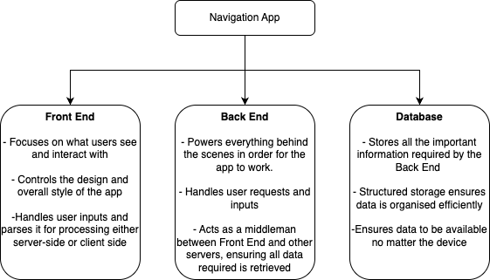
To ensure I cover all aspects of the project in my model, I have decided to split each component of my project into three main areas:
I will explain each of these areas in further detail below. I believe splitting the application into these three areas will allow for me to ensure no part of the project is left unattended and I will have a clear plan and structure for how I am going to implement this idea.

Front End
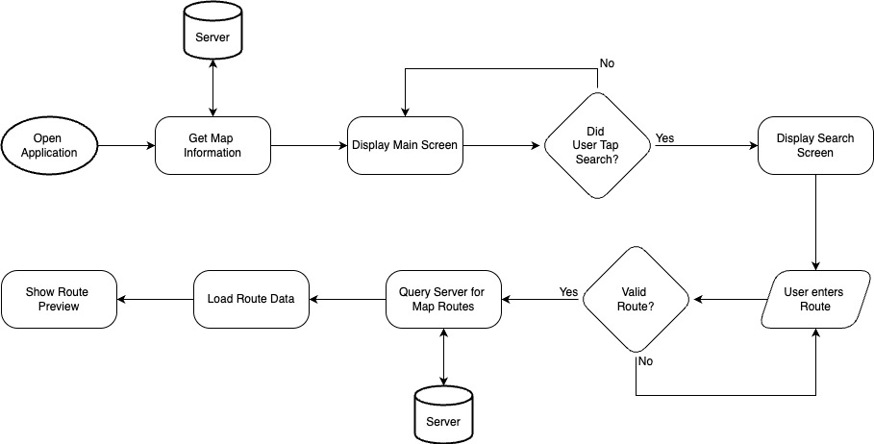
This is a flow chart I have created that outlines how I would expect for this app to run. This breaks up each function of the front end into a clear pathway, ensuring that I stay on task and relevant to my project. The front end will be as simple as possible, only containing essential information and features to help with ease of use. I intend for the front end to be as lightweight as possible, as I want to limit any performance issues that may come from a resource intensive design. This diagram highlights the essential functions required for my app to work, and any technical challenges can be bolted on as an additional process to this flow diagram. The ‘Server’ will act as a gateway to my main server that will serve as a connection point to the database, where all map information will be stored. This design provides me with a solid foundation for what my base application will be and provides clear options to where I can further implement my technical challenges.

Back End
The Back End of this Application is arguably the most important. This part of the project will be where all the major processing occurs and ensures correct function of the app. An efficient development of my backend will allow for seamless integration between my Database and APIs used to the front end, which the user will interact with.
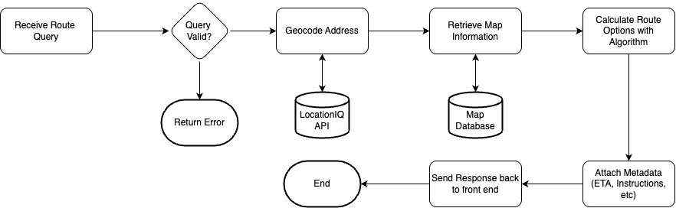
This is another flow diagram highlighting the movement of data between the servers and APIs. In the same method as the front end, this back-end flow diagram allows for a visualisation of the app and makes it easier to identify where technical challenges may be implemented. This part of the application will be the most time consuming to design and code, so it is important that the essential features remain minimal so that I can stay within my timeframe.

Database
The database does not require any code, but instead to be initialised the first time before running the application. This will stay static. I will download data from the OpenStreetMap API and structure this database so that data is stored as efficiently as possible. I will do this utilising linked tables, an advanced way of connecting separate tables in a database using Unique Identifiers. A correct implementation of this will ensure there are no duplicates of data. A reason why this is important is due to the scale of data being stored; Inefficiently storing data can result in an increased file size.

Objectives
This section will include a numbered list of objectives to cover the entire system in detail. These points will be Specific, Measurable, Achievable, Relevant and Timebound (SMART) for this project. I will also further label any stretch objectives with an ‘S’ as well as having separate colours to the main objectives.
1 – Front-End Development
1.1 - User Input Interface
1.1.1 - Create an interface with two clearly labelled input fields (start and destination) and a submit button that allows a route to be generated in no more than seven user interactions.
1.1.2 - Validate inputs by ensuring they are not empty and can be converted into latitude and longitude coordinates using the Nominatim API within one second.
1.1.3 - Display clear error messages (e.g., "Invalid location") within one second when user input is missing or cannot be geocoded.
1.1.4 (S) - Implement autocomplete that displays up to five location suggestions within 500 milliseconds of user input.

1.2 – Map Display
1.2.1 – Integrate OpenStreetMap to display map tiles, roads, and the calculated route on an interactive interface.
1.2.2 – Display the calculated route using a distinct colour and highlight major roads with a different style to ensure the route is clearly visible at all zoom levels.
1.2.3 (S) – Enable zooming and panning with response times under 200 milliseconds while maintaining the visibility and accuracy of the displayed route.

1.3 – Show turn-by-turn directions in a readable format.
1.3.1 – Implement the directions function to generate textual instructions from the route.
1.3.2 - (S) – Ensure directions include road names and turning instructions for clarity.

2 – Back-End Development
2.1 – Route Calculation System
2.1.1 – Implement the A* search algorithm to calculate the shortest path between two points in 2 seconds for typical inputs.
2.1.2 – Ensure the full route calculation process (data loading, graph construction, and pathfinding) completes in under three seconds for inputs within a 2–5 km radius.
2.1.3 – Use heuristics to reduce the number of explored nodes so that no more than 70% of available nodes are processed during pathfinding.
2.1.4 (S) – Apply weighting to prioritise major roads so that they are selected in the majority of long-distance routes.

2.2 – Data Handling and Performance
2.2.1 (S) – Use parallel processing for node creation and neighbour assignment to reduce preprocessing time by at least 30% compared to a single-threaded approach.

2.3 (S) – Integrate optional live traffic data to update routes dynamically.
2.3.1 (S) – Use APIs (Here Maps or TomTom) to retrieve congestion and traffic information.
2.3.2 (S) – Adjust route weights dynamically based on live traffic to provide real-time rerouting.
2.3.3 (S) – Provide alternative routes to avoid congestion or road closures.
2.3.4 (S) – Notify users of estimated delay times and suggest faster routes when available.

3 - Database Design
3.1 – Database Structure
3.1.1 – Create a nodes table with fields id (primary key), latitude, and longitude to store all map node coordinates.
3.1.2 – Create a ways table with fields id (primary key), node_refs, highway, maxspeed, oneway, and junction to store road data.
3.1.3 – Store node_refs as an ordered list of node IDs to represent the structure of each road.

3.2 – Relationships and Integrity
3.2.1 – Ensure that all node IDs in node_refs correspond to valid entries in the nodes table.
3.2.2 – Maintain a one-to-many relationship where each road (way) references multiple nodes.
3.2.3 – Prevent duplicate node or way IDs by enforcing primary key constraints.

3.3 – Data Efficiency
3.3.1 – Store only nodes and ways relevant to routing to minimise database size and improve performance.
3.3.2 – Optimise storage by converting complex structures (e.g., node lists) into compact formats suitable for querying.

3.4 – Data Access and Usage
3.4.1 – Retrieve node coordinates using indexed queries on id to ensure lookup times under one second.
3.4.2 – Query ways efficiently to extract connected nodes for pathfinding operations.
3.4.3 (S) – Utilise a DBMS (Database Management Server) in order to manage queries and prevent corruption.

Design

Description

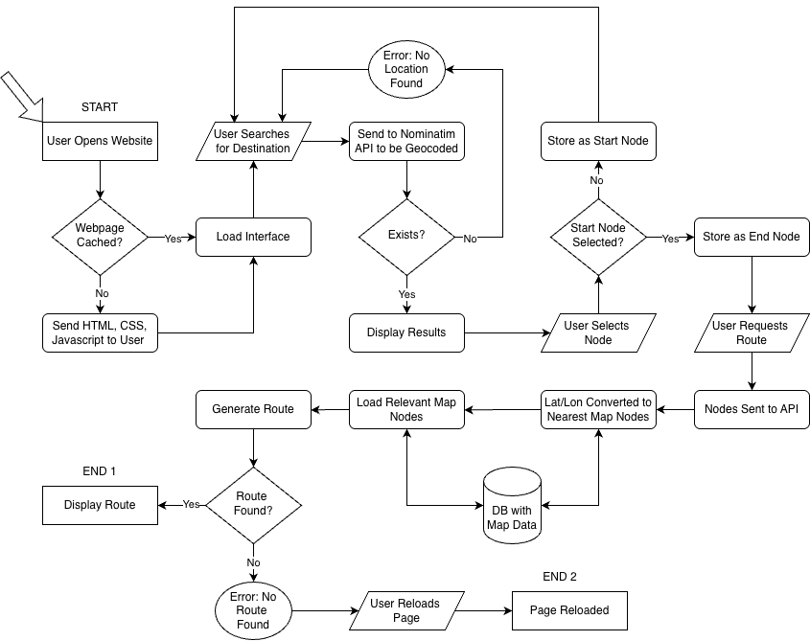
This is a flow chart that I have created to show the flow of data within my system, as well as the processes that occur in the background
To manage the visual representation of the maps, I will use a python library called ‘Folium’ that allows me to plot points by their latitude and longitude onto a simple basemap. This basemap is important as it makes it easier to navigate, displaying other roads that might be nearby. While these roads aren’t being travelled, being able to link it to the user’s surroundings will make it more intuitive for navigation purposes. I will use simple input boxes for destination and start addresses, and when both locations are selected, it will be sent as a JSON API Post Request to the server that handles all the processing. I will use the Nominatim API to map these addresses to a latitude and longitude and then locate the closest node from my map data that I can use for this.
This application will offer a comprehensive and advanced A* Algorithm, where I will spend lots of time refining heuristics to improve the speed of the algorithm as well as helping to find the fastest route. This will be a major part of the algorithm, and the modular programming style will allow me to recurse through and make multiple separate routes that I can then combine.

Interface Design

Explanation
In my user interface, the left side will display the map while beside it I will have a descriptive text analysis of the route that will indicate how, when and where the driver should turn during the route. I will utilise a HTML form input to beside it on the right to collect the information of where the user would like to travel to and from. This will include a simple button that will initiate the routing process. This map will be very interactive, allowing for the user to zoom, scroll, and move it to their liking.

Rough Mock Up
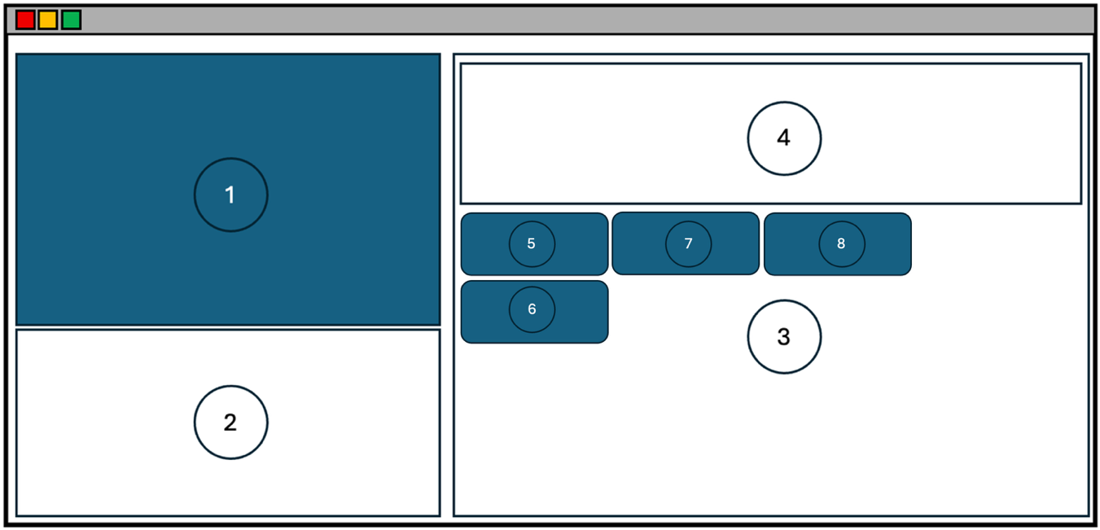

1 | This is where I intend for the map to be displayed. This will be interactive, allowing the user to zoom in, zoom out, and move the map around. This will also be where the route will be shown. I will do this by layering the route over the basemap. I will use the basemap provided by OpenStreetMap through the Folium Library, which I will be using to generate all maps for my project.
2 | This section will include textual directions, allowing the user to scroll through. This will identify any turns, and road changes.
3 | This section will allow for the user to search for where they want the route to start and end from. This will be a simple form that sends a request to the Nominatim API, which then returns 5 of the closest results to the user. This will also contain a ‘Search’ button once the start and end nodes have been selected and a ‘Reset’ button after the first point has been selected, in case the user has made a mistake
4 | This section will clearly display what the user has selected as their start and end node. This is important as it ensures that if the user makes a mistake, they will be able to identify it here and then rechoose their route start/end points.

My front end is extremely simple, and this is important as it meets my goal of keeping the interface intuitive and easy to use.
INPUTS
INPUT | PROCESS | STORAGE | OUTPUT
5  “Search” Button pressed | -User Input from form is taken and sent to the server  - This data is processed through the Geocoding API to resolve the location. | - Information is stored within the Front-End, inside the HTML | - List of Relevant Nodes and their locations  -Displayed textually below the form.
6  “Select” Button pressed | -Node Information of relevant node is pulled from HTML. | -Stored as a constant within JavaScript | - Form is reset and Node is displayed on the screen
7  “Submit” Button pressed | -JavaScript sends a request to the backend for a route, with both Start and End Node | -Route stored as a HTML file once processed | -Loading screen until route is finalised  -Original basemap is removed and replaced with the new generated HTML Map
8  “Reset” Button pressed | -Calls the generic JavaScript ‘reset’ function | - None | - Reloads the page.

Top-Down Diagram
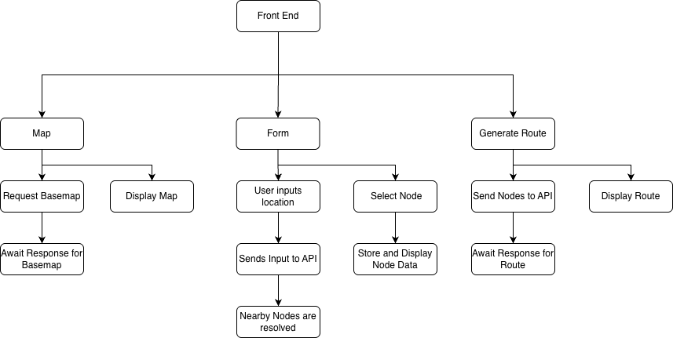
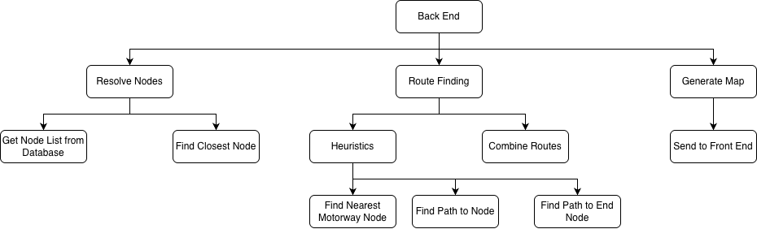

Algorithms & Code
Below, I will provide flowcharts of my code that will outline the processes that I will then be creating in python.

A* Algorithm
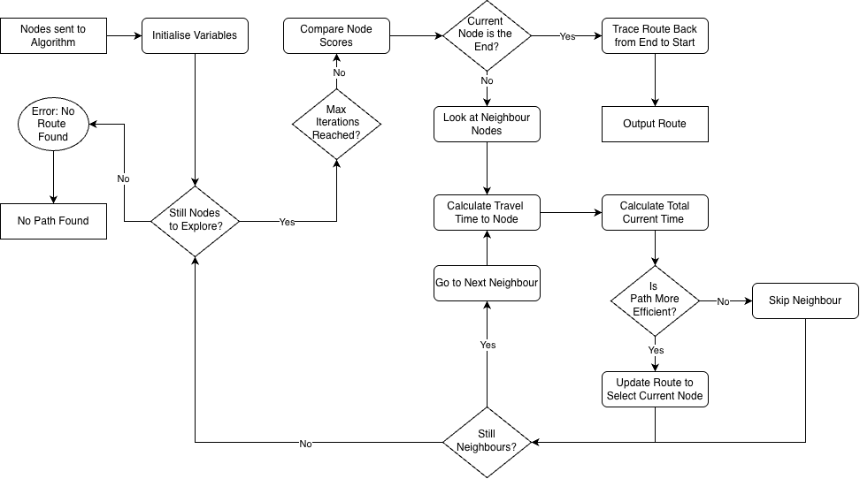
The A* pathfinding algorithm is a widely used search algorithm used to find the shortest path between two points. This is often used in games, robotics, and maps and navigation, which is my current application. It combines the actual cost travelled at whatever point, and the estimated cost to the goal. It evaluates the paths by finding the neighbouring nodes with the lowest total cost, making it very fast and optimal. This is often carried out with a priority queue as it allows for quick sorting of these nodes and easy access.
The process starts by placing the starting point into a queue with a cost of zero. This enters a main loop that runs until the end node is found or no route is found at all. The algorithm will compare the ‘cost’ to travel to each node and pick the node with the lowest cost. From this point, we enter another loop that will check the neighbouring nodes of this node. Once all neighbours are checked, the nearest node will
By using A* Search in the solution, Objectives 2.1.1 and 2.1.4 are achieved because it adds an intelligent pathfinding method, making the overall system very capable and achieves the goal of an efficient routing app.
My algorithm is arguably the most important part of my project, as it is the logic and the brains behind how everything operates. Any issues with either the data parsed, stored, or calculated can skew my results and either reduce the efficiency of the algorithm, or prevent it from accurately finding the shortest route, or finding one in general. In order to ensure efficiency, I had to spend many hours during development finetuning how the algorithm will decide what route to take.
Originally, I followed a tutorial of how to code this algorithm in python for a grid graph implementation. This provided me with the fundamental knowledge of how the algorithm operates and how to code it in. However, the method used for calculating an efficient route consisted solely of a Manhattan distance calculation. Manhattan distance is a method of finding the distance between two points by summing the absolute distance of their cartesian coordinates, commonly used in grid systems. In order to make this more accurate for real world coordinates, I decided to utilise a haversine distance calculation. This was my chosen route as it works with latitude and longitude data and also considers the curvature of the earth and how coordinate values can be skewed depending on their position on a map. This ensures my distance calculations are as accurate as possible. However, in testing, I noticed that the route chosen was often the shortest distance, but it wasn’t the fastest route. While travelling less distance often constitutes a faster journey, sometimes these routes take paths through backroads or towns, which often have slower speed limits compared to faster A-roads or Motorway Roads. This led me into considering road speed limits for my calculations.
Within OSM Way Data, it also includes the speed limits of roads, which was what led me to this idea. Using my already calculated value of distance, I divided this by the respective speed limits of the roads. This provided me my road scores based on the time spent on each road, with the less time the better. Especially on longer journeys, this ensures that the algorithm would correctly travel through A-roads and Motorway Roads as a preference. Often times when driving, travelling via these roads are a lot faster and more efficient than taking other routes, with great transport links and faster speed limits. I then decided to try and further upgrade this algorithm to favour these roads.
Taking inspiration from RPN (Reverse Polish Notation) Algorithms, they often store a dictionary of operators with their relative precedence. This precedence ranks the operators by order of importance, which ensures that they are correctly ordered when calculations are reorganized. I decided to apply this same precedence logic with the different road types. Within my algorithm, I have a constant dictionary listing each road type with their level of precedence. This allows me to further moderate the road scores to force the algorithm to pick the motorway roads. These precedence values are multiplied by a priority factor which is then multiplied onto the individual road scores. This helps to ensure that the better roads are more likely to be selected.
With my time constraints, I believe these optimisations help make my algorithm more accurate, as well as not spending too much time fine tuning.

Pre-Processing of Data
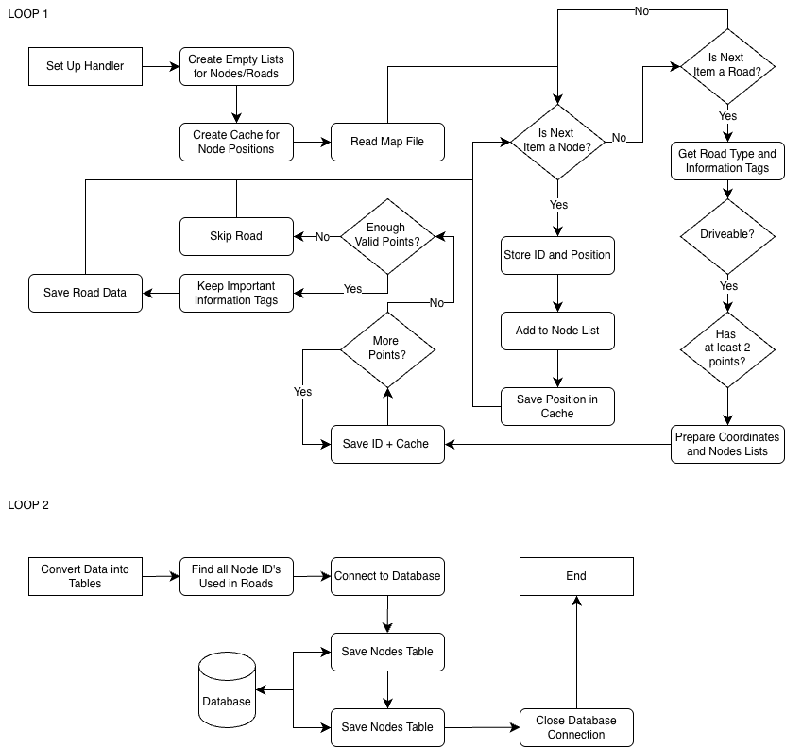
To convert the data into a form that I can manipulate, I need to perform some preprocessing on the data before it even enters the algorithm. The raw data provided from OpenStreetMap is full of a variety of information, a lot of which is unnecessary for my use case. This includes pedestrian pathways, bike paths, etc. I need perform some filtering to only grab driveable routes, as well as any identifying information about these roads. I will be using a python library called Osmium in order to streamline this process. The final data which I end up parsing gets broken up into two separate tables, labelled Ways and Nodes. The Ways table provides all the routes, and which nodes are a part of this. It also includes road names, speed limits, and whether it is only one-way. The Nodes provide more fundamental information about their location, including their node reference number and their respective latitude and longitude values. Together, these tables can be used by my algorithm in order to generate a route.
This meets Objective 2.2.1 and 2.2.3 as it ensures the data remains relevant, and efficiently filters the OpenStreetMap database and handles it efficiently. Objectives 3.3.1, 3.2.1, 3.2.2, 3.2.3 and 3.3.2 are also met.

Filter Node Selection
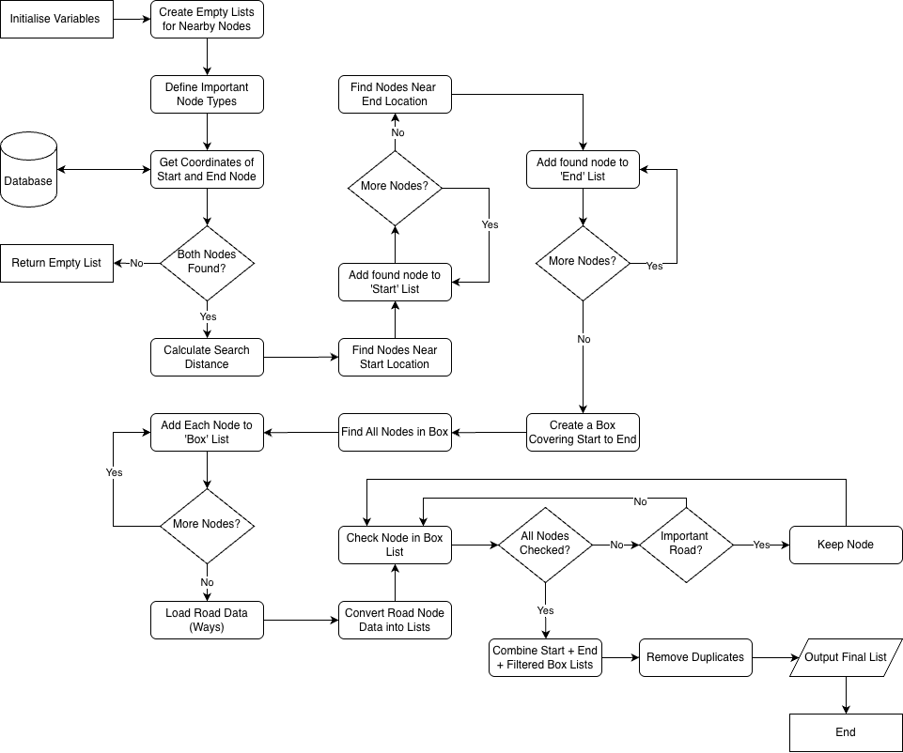
This function filters down the nodes further to help improve the efficiency of the algorithm. This is important as the reducing the data sent to the algorithm will reduce the time needed to compute, making it more efficient. This function creates 3 ‘sections’, where specific nodes are collected. Around the start and end nodes, I collect every node within a set radius so I can ensure that I can navigate from the nodes out. However in-between, the logic is different as I instead gather a ‘box’ of nodes that are between the start node and the end node. This box node only gathers the major roads, as they often provide a faster path, especially on longer distances.
This helps with performance as it takes strain off the system and gives less nodes to look through for the algorithm. This meets Objectives 3.3.1 and 3.3.2

This is a diagram that highlights the logic behind how this function gathers nodes. The Green Dot Represents the Start Node and the End Node. The lighter blue circles highlight a radius around each node and signifies that all nodes are being selected within this region. The Darker Blue represents the box plot, which uses the two nodes as edges. Within this region, only main roads are selected. This helps ensure the route generated is as fast as possible and prevents the possibility of slower roads or random detours being taken by the algorithm. This also meets Objective 2.1.3 as it reduces the number of nodes sent into the algorithm

Create Speed and Neighbour Grids
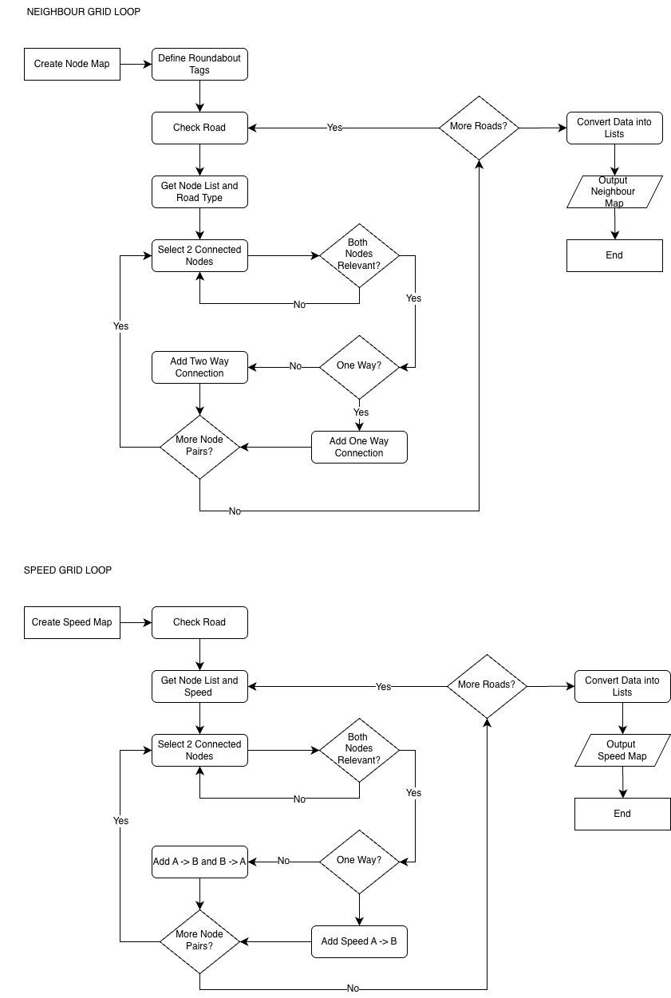
This is important as both grids would be utilised for the algorithm to calculate the lowest cost route as well as identifying any neighbouring nodes. Without this logic, the Algorithm would not be able to navigate at all. The Speed Grid will be used to store the road speeds, and the algorithm will use this information to calculate which roads take the least time to travel towards the destination. The Neighbour Grid is essential as it is the only way that each node is linked with each other. This will store a list of the Node Objects that are linked.

Node Class
As each node contains a lot of information, I have decided to utilise classes to store all information. This provides easy access for the algorithm to all the data based on what node it is and ensures better organisation, furthermore, data can then be updated individually. This also allows me to hit the points of the NEA project, which includes object orientated programming.

Class Variables
Each node will store its ID, Latitude, Longitude and the List of Neighbours . This data does not need to be accessed by the user, so it will all be protected.

Getter Methods
The only variables that will need to be obtained for the algorithm to operate is its ID, Position and its Neighbours. As the variables are only accessible from within the class, I have 3 functions which have a sole purpose of obtaining this information for the algorithm. This keeps all data hidden from the user.

Update Methods
Once the variables are initialised within the class, the only variable that will ever be modified is the neighbours. I only need one function here, which is to modify and add neighbours to the node class.

Database Design
As part of my design phase, I have trialled many different database designs that would both balance organisation and efficiency, especially for my algorithm. I have found that when storing data in 3NF (3rd Normal Form), My algorithm struggled to find a link between nodes, if finding a route at all. The time taken for the algorithm increased exponentially and its reliability had tanked. I instead resorted to an un-normalised form of a database. While this isn’t ideal, this allowed me to keep my node initialisation and route finding all under a couple of seconds of processing. I have a ‘Node’ table, storing Node ID and its coordinates, and I also have a ‘Ways’ Table, storing Way ID, a list of Node IDs within that way, as well as general road information. The part of this database where it isn’t normalised is in how the Way Nodes are stored. I have stored them all into one cell and as a list, which means that there are multiple key dependencies within the table, therefore being unnormalized. This is intentional, as it means that the algorithm only requires minimal database calls to get all the information required. Furthermore, this reduces strain on the database, which could result in slower times due to the database being overloaded, or corrupted records from two clients attempting to access at the same time.
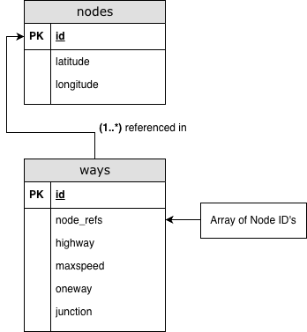
This is a simple Entity Relationship Diagram showing how I will structure my database. At its simplest form, the connections will be a one-to-many connection. This is due to nodes potentially having multiple roads and directions of travel from it. The ‘nodes’ Table will include all the relevant information on each node, being solely its latitude and longitude. This will allow for easy filtration of table records, which is especially important when getting nodes for my algorithm. The ‘highway’ row in my ‘ways’ table will refer to what type of road the node is on (motorway, etc). By labelling the type of road the node is on, this allows for optimised heuristics to be utilised when finding a route, such as taking major roads instead of back roads. This makes algorithm implementation a lot easier and can make the route-finding more efficient. The ‘node_refs’ table will be a list of id’s from my nodes table. This is where how the links between the nodes are established, and being grouped together ensures it is more efficient in its search. This is also important as now routes can be filtered through by Node ID. This will include information such as the speed of the road, a Boolean Value of whether the road is one-way or two -way, and if it is a roundabout node. This meets Objectives 3.1.1, 3.1.2, 3.1.3 and 3.2.2
Live Traffic can be implemented by having an additional row that records the level of traffic within a set scale. This may be a challenge to implement without causing strain to the server, however there could be an on-demand style setup to negate this. Before grabbing map data from the database, it can request live data for the area surrounding both destination and source nodes, plus everywhere in-between. This can then be updated into the table, before being utilised by the search algorithm. This ensures up-to-date information on live traffic and limits the effect on server resources. This may be implemented through a database management server (DBMS) to ensure records aren’t modified simultaneously.
Below I will highlight all the different queries that I will use within my code to communicate with the Database, as well as a brief description of its purpose

Node Initialisation
Query | Purpose
"SELECT * FROM ways" | Select all roads stored in the database
'SELECT id FROM nodes ' \  'ORDER BY ABS(latitude - ?) + ABS(longitude - ?) ' \  'LIMIT 1;' | If the Latitude and Longitude Values Geocoded by the Nominatim API do not have a direct node within the database, this query will select the first Node that is the closest in absolute distance to these values.
SELECT latitude, longitude FROM nodes WHERE id = ? | Searches for an individual node by its Node ID and gets its coordinate values.

Node Filtration
Query | Purpose
"SELECT node_refs, highway FROM ways" | Select All the Roads within the Database as well as the Road Type
"SELECT id, latitude, longitude FROM nodes WHERE latitude BETWEEN ? AND ? AND longitude BETWEEN ? AND ?" | Selects all Nodes within a box, providing a set a Latitude and Longitude Range to filter out Nodes by

This all meets Objective 3.4.1 and 3.4.2

Data Initialisation
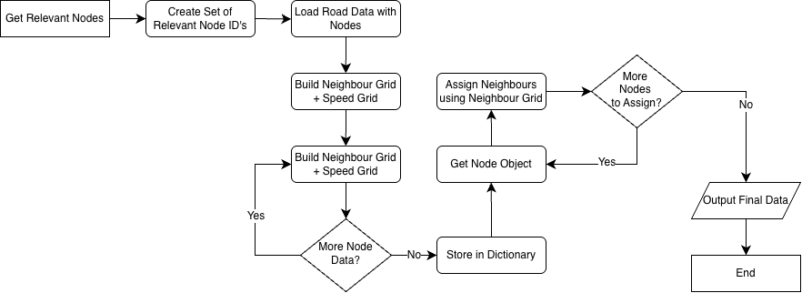
This is a flowchart of a function I will create that will initialise all essential data for the route to be calculated. Rather than individually calling each function to reload variables, this function will group the node filtration, neighbour assignation and speed map generation into one function making it easier to load required data. From here, the data can then easily be passed onto the algorithm.

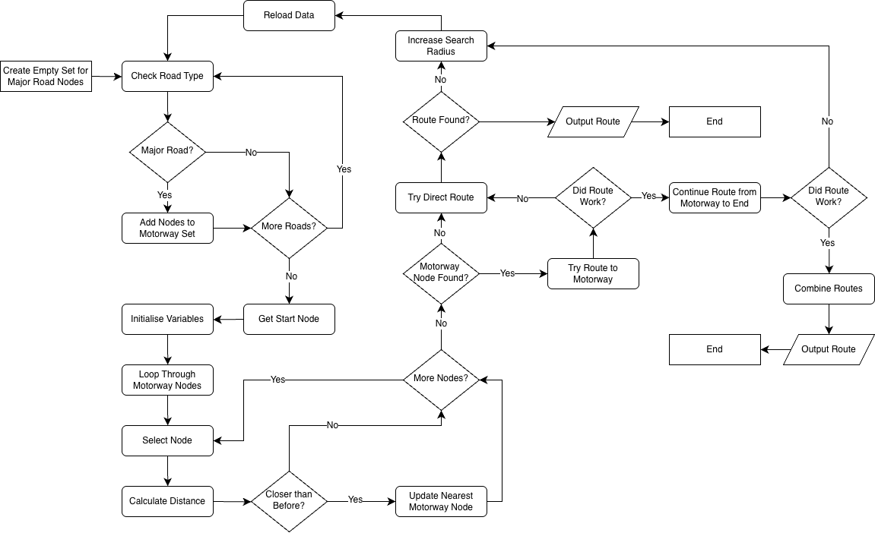
Heuristics

The heuristically approach of the algorithm is how the A* Algorithm is classed as a “Smart” algorithm; my main idea was to implement a search for the nearest motorway node to the start point. Returning back to the point prior, motorways are often the fastest and most efficient routes to take when travelling. With this general knowledge, I searched a radius around the start node and recursively searched through each motorway node in that radius until a route was found within a set count rate. This count rate limits the number of iterations that the algorithm has before it stops searching. This ensures that the algorithm doesn’t spend too long and too much processing power finding it rather than looking elsewhere. Additionally, the pathway to a motorway node sometimes might not be as efficient, so this count rate is set to avoid taking too much of a detour. Once the pathway to the motorway is found, it will find the rest of the route from that node to the end node and combine the two into one. If no motorway node is found or they are all out of the set bounds, The heuristics simply finds a direct route between the two locations. This meets Objective 2.1.3

Directions

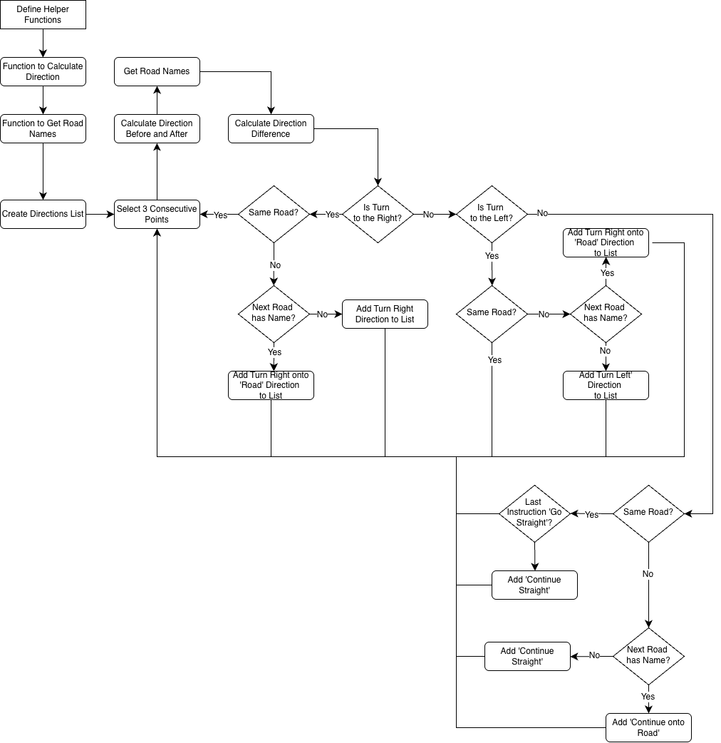
This is the flowchart for how I will create the textual directions. This will recurse through the generated route after it has been created by the algorithm and use the Ways Data from the Database to pull any names that are available. This will then be displayed to the user in a scrollable form on the interface. This meets Objective 1.3, 1.3.1 and 1.3.2, by displaying textual directions, as well as with road names.

Technical Solution

App.py
from flask import Flask, render_template, request, jsonify, make_response
import requests
from mapgen import *
from pathfinding import *

# Create Flask application
app = Flask(__name__)

# Home route
@app.route('/')
def index():
return render_template('base.html')

@app.route('/api/forward', methods=['POST'])
def address_search():
query = request.form.get('search', '')
query = query.replace(' ', '+')
url = 'https://nominatim.openstreetmap.org/search'
params = {'q': query + ', UK', 'format': 'json', 'limit': 5}
headers = {'User-Agent': 'CS-NEA/1.0 ROUTE'}
response = requests.get(url, params=params, headers=headers, timeout=10)
try:
response.raise_for_status() # raises HTTPError for 4xx/5xx responses
except requests.exceptions.HTTPError as e:
print("Request failed:", e)
print("Status code:", response.status_code)
print("Body:", response.text)
# handle or re-raise
else:
data = response.json()
keep_keys = ('name','display_name', 'lat','lon')
filtered = [{k: item[k] for k in keep_keys if k in item} for item in data]
return filtered

@app.route('/api/basemap', methods=['GET'])
def generate_basemap():
html = create_uk_basemap()
return make_response(html, 200, {'Content-Type': 'text/html'})

@app.route('/api/route', methods=['POST'])
def find_route():
data = request.get_json()
start = (float(data['start']['lat']), float(data['start']['lon']))
end = (float(data['end']['lat']), float(data['end']['lon']))

final_route = route(start, end)

final_map = plot(final_route[0])
return jsonify({'route': final_map, 'directions': final_route[1]})

if __name__ == '__main__':
app.run(debug=True)

pathfinding.py
import math as m # For Algorithm
import heapq # For Algorithm
import time # Displaying time taken to find a path
import ast # Parsing Data
import pandas as pd # Data Organisation
import sqlite3 as sql # Database

from concurrent.futures import ThreadPoolExecutor, wait # Threading

from collections import deque # Troubleshooting

class Node: # Establishes Node Class with Methods
def __init__(self, node_id, lat, lon):
self._node_id = node_id
self._lat = lat
self._lon = lon
self._neighbours = [] # Lists Neighbours
# ////////////////////////////// #
def get_pos(self):
return self._lat, self._lon
def get_id(self):
return self._node_id
def get_neighbours(self):
return self._neighbours
# ////////////////////////////// #
def update_neighbours(self, neighbours):
self._neighbours = neighbours
# ////////////////////////////// #

def haversine(p1, p2): # Accurate Distance Calculations
lat1, lon1 = p1
lat2, lon2 = p2

delta_lon = m.radians(lon2-lon1)
delta_lat = m.radians(lat2-lat1)

a = m.sin(delta_lat)**2 + m.cos(m.radians(lat1)) * m.cos(m.radians(lat2)) * m.sin(delta_lon/2)**2

angle = 2 * m.atan2(m.sqrt(a), m.sqrt(1-a))
return 6731 * angle #6731 = approx radius of the earth

def algorithm(start, end, edge_speeds, edge_roadtypes=None, max_count=None, priority_factor = 0.8):

count = 0 # For Heuristically Searching
open_set = []

heapq.heappush(open_set, (0, 0, count, start))

# Ordered precedence for driving highways (lower value = higher priority)
DRIVING_HIGHWAY_PRECEDENCE = {
'motorway': 0, 'motorway_link': 0,
'trunk': 0, 'trunk_link': 0,
'primary': 6, 'primary_link': 6,
'secondary': 8, 'secondary_link': 8,
'tertiary': 10, 'tertiary_link': 10,
'unclassified': 9, 'residential': 10,
'living_street': 12, 'service': 12, 'road': 9,
}

if max_count is None:
max_count = m.inf

default_speed_kmph = 40 * 1.60934

came_from = {}
g_score = {start: 0.0} # Initialise Start Node, has been "Explored" so set to 0

# initial heuristic: straight-line distance (km)
initial_h = haversine(start.get_pos(), end.get_pos())
f_score = {start: initial_h / default_speed_kmph}

while open_set:
if count >= max_count:
return False # Heuristic Stop Case

_, _, _, current = heapq.heappop(open_set)

if current == end:
# Reconstruct path by walking back through visited nodes.
path = [current]
while current in came_from:
current = came_from[current]
path.append(current)
return path[::-1]

for neighbour in current.get_neighbours():
edge = (current.get_id(), neighbour.get_id())
speed_kmph = edge_speeds.get(edge)

# geometric distance of this edge (km)
edge_distance_km = haversine(current.get_pos(), neighbour.get_pos())

# Protection against missing speed value,
if not speed_kmph or speed_kmph == 0:
speed_kmph = 50

# time-based cost (hours) with precedence penalty (older behaviour)
speed_kmph = edge_speeds.get(edge)
if not speed_kmph or speed_kmph == 0:
speed_kmph = 50 # fallback km/h
base_travel_time = edge_distance_km / speed_kmph # hours

precedence = DRIVING_HIGHWAY_PRECEDENCE.get(
edge_roadtypes.get(edge) if edge_roadtypes else None,
max(DRIVING_HIGHWAY_PRECEDENCE.values()) + 1
)

edge_cost = base_travel_time * (1 + precedence * priority_factor)

tentative_g = g_score[current] + edge_cost

if neighbour not in g_score or tentative_g < g_score[neighbour]:
came_from[neighbour] = current
g_score[neighbour] = tentative_g

# heuristic: remaining distance (km) OR remaining time depending on mode
remaining_distance_km = haversine(neighbour.get_pos(), end.get_pos())

heuristic = remaining_distance_km / default_speed_kmph
f_score[neighbour] = tentative_g + heuristic

count += 1
# use precedence as second sorting key to prefer higher quality roads on ties
precedence = DRIVING_HIGHWAY_PRECEDENCE.get(
edge_roadtypes.get(edge) if edge_roadtypes else None,
max(DRIVING_HIGHWAY_PRECEDENCE.values()) + 1
)
heapq.heappush(open_set, (f_score[neighbour], precedence, count, neighbour))
return False

def get_relevant_nodes(conn, start, end, radius):
cursor = conn.cursor()

def resolve_node(val):
finding_query = 'SELECT id FROM nodes ' \
'ORDER BY ABS(latitude - ?) + ABS(longitude - ?) ' \
'LIMIT 1;'

coordinate_query = "SELECT latitude, longitude FROM nodes WHERE id = ?"

# If coords Provided:
if isinstance(val, (list, tuple)) and len(val) == 2: # Guard to check if the value provided is a coordinate
lat, lon = float(val[0]), float(val[1])

cursor.execute(finding_query, (lat, lon))
node_id = cursor.fetchone()
if not node_id:
return None, None
node_id = node_id[0] # Ensure that the ID is selected, no other values with it

cursor.execute(coordinate_query, (node_id,))
coords = cursor.fetchone()
return node_id, coords
# If node ID Provided:
try:
node_id = int(val)
cursor.execute(coordinate_query, (node_id,))
coords = cursor.fetchone()
if not coords:
return None, None
return node_id, coords
except Exception:
return None, None

start_id, startnode = resolve_node(start)
end_id, endnode = resolve_node(end)

if not start_id or not end_id or not startnode or not endnode:
return None, None, []

start_nearby = []
end_nearby = []

box_nodes_cache = []
box_nodes = []

MOTORWAY = {
'motorway', 'motorway_link',
'trunk', 'trunk_link',
'primary'
}

lat1, lon1 = startnode
lat2, lon2 = endnode
delta_deg = radius / 111.0 # approximates lat/lon to km
query = "SELECT id, latitude, longitude FROM nodes WHERE latitude BETWEEN ? AND ? AND longitude BETWEEN ? AND ?"

cursor.execute(
query,
(lat1 - delta_deg, lat1 + delta_deg, lon1 - delta_deg, lon1 + delta_deg)
)
for row in cursor.fetchall():
start_nearby.append({'id': row[0], 'lat': row[1], 'lon': row[2]})

cursor.execute(
query,
(lat2 - delta_deg, lat2 + delta_deg, lon2 - delta_deg, lon2 + delta_deg)
)
for row in cursor.fetchall():
end_nearby.append({'id': row[0], 'lat': row[1], 'lon': row[2]})

min_lat, max_lat = min(lat1, lat2), max(lat1, lat2)
min_lon, max_lon = min(lon1, lon2), max(lon1, lon2)

cursor.execute(
query,
(min_lat, max_lat, min_lon, max_lon)
)
for row in cursor.fetchall():
box_nodes.append({'id': row[0], 'lat': row[1], 'lon': row[2]})

# read ways and ensure node_refs parsed to lists
df = pd.read_sql("SELECT node_refs, highway FROM ways", conn)
df['node_refs'] = df['node_refs'].apply(lambda x: ast.literal_eval(x) if isinstance(x, str) else x)

for row in box_nodes_cache:
roadtypes = df[df['node_refs'].apply(lambda x: row[0] in x)]['highway']
if any(road in MOTORWAY for road in roadtypes):
box_nodes.append(row)

all_nodes = start_nearby + end_nearby + box_nodes

# removes duplicates by node id
unique_nodes = {node['id']: node for node in all_nodes}
relevant_nodes = list(unique_nodes.values())

return start_id, end_id, relevant_nodes

def preload_ways(conn, relevant_nodes):
df = pd.read_sql("SELECT * FROM ways", conn)

# converts all the strings into lists
df['node_refs'] = df['node_refs'].apply(lambda x: ast.literal_eval(x) if isinstance(x, str) else x)

# filter ways for those that contain relevant nodes
df = df[df['node_refs'].apply(lambda x: any(node in relevant_nodes for node in x))]
return df

def build_grids(df, relevant_nodes):
neighbour_grid = {node_id: set() for node_id in relevant_nodes}
ROUNDABOUTS = {'roundabout', 'circular'}
road_types = {}
for _, row in df.iterrows():
node_refs = row['node_refs']
road_type = row.get('highway')
is_oneway = row.get('oneway', None) == 'yes'
is_roundabout = row.get('junction', None) in ROUNDABOUTS
for i in range(len(node_refs) - 1):
a, b = node_refs[i], node_refs[i+1]
if a in neighbour_grid and b in neighbour_grid:
# For one-way or roundabout: only allow a -> b
if is_oneway or is_roundabout:
neighbour_grid[a].add(b)
# For two-way: allow both directions
else:
neighbour_grid[a].add(b)
neighbour_grid[b].add(a)

road_types[(a, b)] = road_type
if not is_oneway:
road_types[(b, a)] = road_type
# convert sets into a list
for node in neighbour_grid:
neighbour_grid[node] = list(neighbour_grid[node])

edge_speeds = {}
for _, row in df.iterrows():
node_refs = row['node_refs']
speed_str = row.get('maxspeed', None)
if isinstance(speed_str, str) and 'mph' in speed_str:
speed = float(speed_str.replace(' mph', '').strip())
else:
try:
speed = float(speed_str) * 1.60934
except (TypeError, ValueError):
speed = 50 * 1.60934 # default speed if missing
is_oneway = row.get('oneway', None) == 'yes'
for i in range(len(node_refs) - 1):
a, b = node_refs[i], node_refs[i+1]
if a in relevant_nodes and b in relevant_nodes:
edge_speeds[(a, b)] = speed
if not is_oneway:
edge_speeds[(b, a)] = speed

return neighbour_grid, edge_speeds, road_types

def initialise_nodes(conn, first, last, radius):
nodes_dict = {}
start_time = time.time()
first, last, node_data = get_relevant_nodes(conn, first, last, radius)

relevant_nodes = set([data['id'] for data in node_data])
ways = preload_ways(conn, relevant_nodes)

neighbour_grid, speeds, road_types = build_grids(ways, relevant_nodes)

def create_node(data):
return data['id'], Node(data['id'], data['lat'], data['lon'])

with ThreadPoolExecutor() as exec:
results = list(exec.map(create_node, node_data))
nodes_dict = dict(results)

def assign_neighbours(node_id):
obj = nodes_dict[node_id]
obj.update_neighbours([nodes_dict[ref] for ref in neighbour_grid[node_id] if ref in nodes_dict])

with ThreadPoolExecutor() as exec:
list(exec.map(assign_neighbours, nodes_dict.keys()))

end_time = time.time()

def bfs(start, end, neighbour_grid):
visited = set()
queue = deque([start])
while queue:
node = queue.popleft()
if node == end:
return True
visited.add(node)
for n in neighbour_grid[node]:
if n not in visited:
queue.append(n)
return False

print("Is path possible?", bfs(first, last, neighbour_grid))

print(f"Data parsing took {end_time - start_time:.4f} seconds")

return ways, nodes_dict, first, last, ways, speeds, road_types

def heuristics(conn, nodes_dict, first, last, ways, speeds, road_types, radius=2):

motorway_nodes = set()
for _, row in ways.iterrows():
if row.get('highway', None) in ['trunk_link', 'trunk', 'motorway_link', 'motorway', 'primary']:
motorway_nodes.update(row['node_refs'])

start_node = nodes_dict.get(first)

if start_node is None:
return False

min_dist = m.inf
nearest_motorway_node_id = None

for node_id in motorway_nodes:
if node_id in nodes_dict:
dist = haversine(start_node.get_pos(), nodes_dict[node_id].get_pos())
if dist < min_dist:
min_dist = dist
nearest_motorway_node_id = node_id

if nearest_motorway_node_id is None:
route = algorithm(nodes_dict[first], nodes_dict[last], speeds, road_types)
if not route:
radius = radius * 1.3
_, nodes_dict, first, last, ways, speeds, road_types = initialise_nodes(conn, first, last, radius)
return heuristics(conn, nodes_dict, first, last, ways, speeds, radius)
else:
return route
else:
route_to_motorway = algorithm(nodes_dict[first], nodes_dict[nearest_motorway_node_id], speeds, road_types, 50)
if not route_to_motorway:
route = algorithm(nodes_dict[first], nodes_dict[last], speeds)
if not route:
radius = radius * 1.3
_, nodes_dict, first, last, ways, speeds, road_types = initialise_nodes(conn, first, last, radius)
return heuristics(conn, nodes_dict, first, last, ways, speeds, road_types, radius)
else:
return route
else:
next_start = nodes_dict[route_to_motorway[-1].get_id()]
route_from_motorway = algorithm(next_start, nodes_dict[last], speeds, road_types)
if not route_from_motorway:
radius = radius * 1.3
_, nodes_dict, first, last, ways, speeds, road_types = initialise_nodes(conn, first, last, radius)
return heuristics(conn, nodes_dict, first, last, ways, speeds, road_types, radius)
else:
return route_to_motorway[:-1] + route_from_motorway

def directions(df, route):
def bearing(p1, p2):
p1 = p1.get_pos()
p2 = p2.get_pos()
lat1, lon1 = m.radians(p1[0]), m.radians(p1[1])
lat2, lon2 = m.radians(p2[0]), m.radians(p2[1])
dlon = lon2 - lon1
x = m.sin(dlon) * m.cos(lat2)
y = m.cos(lat1)*m.sin(lat2) - m.sin(lat1) * m.cos(lat2) * m.cos(dlon)
return (m.degrees(m.atan2(x, y)) + 360) % 360

def roadname(p1, p2):
p1 = p1.get_id()
p2 = p2.get_id()

# Find road containing p1
current_roads = df[df['node_refs'].apply(lambda refs: p1 in refs)]
if current_roads.empty:
currentroad = None
else:
currentroad = current_roads.iloc[0].get('name', current_roads.iloc[0].get('ref', current_roads.iloc[0].get('highway')))

# Find road containing p2
next_roads = df[df['node_refs'].apply(lambda refs: p2 in refs)]
if next_roads.empty:
nextroad = None
else:
nextroad = next_roads.iloc[0].get('name', next_roads.iloc[0].get('ref', next_roads.iloc[0].get('highway')))

return [currentroad, nextroad]

directions = ['Start']
for i in range(1, len(route)-1):
b1 = bearing(route[i-1], route[i])
b2 = bearing(route[i], route[i+1])
roads = roadname(route[i-1], route[i])

diff = (b2 - b1 + 540) % 360 - 180 # normalized -180..180

if diff > 15:
if roads[0] == roads[1]:
pass
else:
if roads[1] is None:
directions.append("Turn right")
else:
directions.append(f"Turn right onto {roads[1]}")
elif diff < -15:
if roads[0] == roads[1]:
pass
else:
if roads[1] is None:
directions.append(f"Turn left")
else:
directions.append(f"Turn left onto {roads[1]}")
else:
if roads[0] == roads[1]:
if directions[-1] == "Continue straight":
pass
else:
directions.append("Continue straight")
else:
if roads[1] is None:
directions.append("Continue straight onto Unknown Road")
else:
directions.append(f"Continue straight onto {roads[1]}")

directions.append('End')
return directions

def route(start, end, radius=2, conn=None):
# create DB connection in the same thread that handles the request
close_conn = False
if conn is None:
conn = sql.connect('Database/MapData.sqlite')
close_conn = True

try:
df, nodes_dict, first, last, ways, speeds, road_types = initialise_nodes(conn, start, end, radius)
path = heuristics(conn, nodes_dict, first, last, ways, speeds, road_types, radius)
direction = directions(df, path)
return path, direction
finally:
if close_conn:
conn.close()

Osmparse.ipynb
import osmium as osm
import pandas as pd
import geopandas as gpd
from shapely.geometry import Point, LineString
import numpy as np
import sqlite3 as sql
import ast
np.set_printoptions(legacy='1.25')

class OSMHandler(osm.SimpleHandler):
def __init__(self, filter_tags=None):
osm.SimpleHandler.__init__(self)
self.nodes = []
self.ways = []
self.relations = []
self.filter_tags = filter_tags or {}
self.node_cache = {}

def node(self, n):
tags = {tag.k: tag.v for tag in n.tags}

self.nodes.append({
'id': n.id,
'latitude': n.location.lat,
'longitude': n.location.lon

})

self.node_cache[n.id] = (n.location.lon, n.location.lat)

def way(self, w):
# Highway types suitable for car navigation
KEEP_TAGS = {'highway', 'oneway', 'name', 'maxspeed', 'junction'}
CAR_HIGHWAY_TYPES = {
# Major highways
'motorway', 'motorway_link',
'trunk', 'trunk_link',
'primary', 'primary_link',
'secondary', 'secondary_link',
'tertiary', 'tertiary_link',

# Local roads
'residential', 'unclassified',
'living_street', 'service',

# Unknown but potentially driveable
'road'

# Roundabouts
'mini_roundabout', 'turning_circle',
'turning_loop'
}

tags = {tag.k: tag.v for tag in w.tags}

highway_type = tags.get('highway')

if highway_type not in CAR_HIGHWAY_TYPES:
return

if len(w.nodes) >= 2:
coords = []
node_refs = []

for node in w.nodes:
node_refs.append(node.ref)

if node.ref in self.node_cache:
coords.append(self.node_cache[node.ref])

if len(coords) >= 2:

filtered_tags = {k: v for k, v in tags.items() if k in KEEP_TAGS}

self.ways.append({
'id': w.id,
'node_refs': node_refs,
**filtered_tags
})

way_filter = {'highway': True}

handler = OSMHandler(way_filter)
handler.apply_file("beds.pbf")

print(f"Nodes parsed: {len(handler.nodes)}")
print(f"Ways parsed: {len(handler.ways)}")
print()
nodes_df = pd.DataFrame(handler.nodes)
ways_df = pd.DataFrame(handler.ways)

# Convert node_refs strings back to lists

# Get all node IDs used in ways
used_node_ids = set()
for refs in ways_df['node_refs']:
used_node_ids.update(refs)

filtered_node_ids = set(nodes_df['id'])

missing_nodes = used_node_ids - filtered_node_ids
extra_nodes = filtered_node_ids - used_node_ids

print(f"Missing nodes (in ways but not in nodes_df): {missing_nodes}")
print(f"Extra nodes (in nodes_df but not in ways): {len(extra_nodes)}")
print(f"Total nodes in nodes_df: {len(filtered_node_ids)}")
print(f"Total nodes referenced in ways: {len(used_node_ids)}")
print()
# Filter nodes_df to only keep nodes in used_node_ids
nodes_df = nodes_df[nodes_df['id'].isin(used_node_ids)]
print(f"Total nodes in nodes_df after filtering: {len(nodes_df)}")

with pd.option_context('display.max_columns', None):
display(nodes_df)
display(ways_df)

# Connect to (or create) the database
conn = sql.connect("Database/MapData.sqlite")

# Insert nodes_df as a table
nodes_df.to_sql("nodes", conn, if_exists="replace", index=False)

# Insert ways_df as a table
ways_df['node_refs'] = ways_df['node_refs'].apply(lambda x: str(x))
ways_df.to_sql("ways", conn, if_exists="replace", index=False)

conn.close()

Mapgen.py
import folium

def create_uk_basemap(zoom_start: int = 6, tiles: str = "OpenStreetMap"):
# centre roughly over Great Britain
uk_center = (54.0, -2.0)
m = folium.Map(location=uk_center, zoom_start=zoom_start, tiles=tiles)
folium.TileLayer(tiles=tiles).add_to(m)
folium.LayerControl().add_to(m)
return m.get_root().render()

def plot(route):
coordinates = [(node.get_pos()[0], node.get_pos()[1]) for node in route]

m = folium.Map(location=coordinates[0], zoom_start=14, tiles='OpenStreetMap')

folium.PolyLine(
coordinates,
color = "blue",
weight = 5,
opacity = 0.8
).add_to(m)

folium.Marker(coordinates[0], popup="Start", icon=folium.Icon(color="green")).add_to(m)
folium.Marker(coordinates[-1], popup="End", icon=folium.Icon(color="red")).add_to(m)

return m.get_root().render()

Base.html
<!DOCTYPE html>
<html lang="en">
<head>
<meta charset="UTF-8">
<meta name="viewport" content="width=device-width, initial-scale=1.0">
<title>Document</title>
<link rel="stylesheet" href="{{ url_for('static', filename='styles.css') }}">
<script src="{{url_for('static', filename='script.js')}}"></script>
<title>A* Route-Finder</title>
</head>
<body>
<div class="parent">
<div class="div2" id="loading_overlay"> <div class="loader"></div> </div>
<div class="div1" id="map"> </div>
<div class="div6" id="route">
<h3>Directions</h3>
</div>
<div class="div3" id="nodes"> </div>
<div class="div4" id="address_list">
<form id="resolve_address">
<label for="search">Address Search:</label>
<input name="search" id="search" type="text" placeholder="Enter Address Here">
<button id="address_submit" type="submit">Search</button>
</form>

<div id="results"> </div>
<button class="blue-btn hide" id="request_route"> Search </button>
<button class="reset hide" id="reset" onclick="location.reload()"> Reset </button>
</div>

</div>
</body>
</html>

Script.js
document.addEventListener('DOMContentLoaded', () => {
const form = document.getElementById('resolve_address');
const results = document.getElementById('results');
const nodes = document.getElementById('nodes');
const map = document.getElementById("map");
const overlay = document.getElementById('loading_overlay');
const reset = document.getElementById('reset');
const request_route = document.getElementById('request_route');
const nodepath = document.getElementById('route')

async function request_basemap() {
try {
const response = await fetch('/api/basemap', {
method: 'GET'
});

if (!response.ok) throw new Error(`HTTP ${response.status} ${response.statusText}`);

const basemap = await response.text();

const iframe = document.createElement('iframe')
iframe.srcdoc = basemap;
iframe.width = '100%'
iframe.height = '100%';
iframe.style.display = 'block';
iframe.style.pointerEvents = 'auto';
iframe.tabIndex = 0;

iframe.addEventListener('load', () => {
try { iframe.contentWindow.focus(); } catch (err) { console.warn('iframe focus failed', err); }
console.log('iframe loaded');
});

if (!map) {
console.error('map element not found; cannot append iframe');
return;
}
map.innerHTML = '';
map.appendChild(iframe);
console.log('iframe appended');

}
catch (e) {
console.error(e);
if (map) map.innerHTML = `<div class="error">Error: ${escapeHtml(e.message)}</div>`;
}
};

request_basemap()

if (!form) console.error('No <form> element found on the page.');

async function search(event) {
event.preventDefault(); // stop page reload / default submit

const formData = new FormData(form);
console.log(...formData); // optional - inspect submitted pairs

try {
const response = await fetch('/api/forward', {
method: 'POST',
body: formData // send multipart/form-data; change if your API expects JSON
});

if (!response.ok) throw new Error(`HTTP ${response.status} ${response.statusText}`);

// parse JSON response
const items = await response.json();

results.innerHTML = ''; // Clear previous contents

// normalize response into an array
let list;
if (Array.isArray(items)) {
list = items;
} else if (items && Array.isArray(items.items)) {
list = items.items;
} else if (items && Array.isArray(items.results)) {
list = items.results;
} else if (items && (items.display_name || items.name || items.lat || items.lon)) {
list = [items];
} else {
list = [];
}

if (list.length === 0) {
results.innerHTML = '<div class="info">No results returned.</div>';
return;
}

// render each result; keep latitude and longitude separate
list.forEach((item, index) => {
const name = item.display_name || item.name || item.title || '';
// common keys: Nominatim -> lat, lon (strings)
const lat = item.lat ?? item.latitude ?? (item.location && item.location.lat) ?? '';
const lon = item.lon ?? item.longitude ?? (item.location && item.location.lon) ?? '';

const div = document.createElement('div');
div.id = `section-${index}`;
div.classList.add('item');
div.innerHTML = `
<strong id="name-${index}">${escapeHtml(name)}</strong>
<div id="coords-${index}" class="coords">
<span class="lat"><em>${escapeHtml(lat)}</em></span>
<span class="lon"><em>${escapeHtml(lon)}</em></span>
</div>
<pre class="raw">${escapeHtml(JSON.stringify(item, null, 2))}</pre>
<button id="select_address-${index}" type="button" class="select-btn">Select</button>
`;
results.appendChild(div);
});

} catch (e) {
console.error(e);
if (results) results.innerHTML = `<div class="error">Error: ${escapeHtml(e.message)}</div>`;
}
};

async function get_route() {
const start = globalThis.START;
const end = globalThis.END;

overlay.classList.add('active');
overlay.style.display = 'flex';

try {
const response = await fetch('/api/route', {
method: 'POST',
headers: { 'Content-Type': 'application/json' },
body: JSON.stringify({ start, end })
});
if (!response.ok) throw new Error(`HTTP ${response.status} ${response.statusText}`);
const route = await response.json();

overlay.classList.remove('active');
overlay.style.display = 'none';

const iframe = document.createElement('iframe')
iframe.srcdoc = route['route'];
iframe.style.width = '100%';
iframe.style.height = '100%';
iframe.style.border = 'none';
iframe.style.display = 'block';
iframe.tabIndex = 0;

let list = route['directions'];
nodepath.innerHTML = '<h3>Directions</h3>'; // Clear previous
list.forEach((item, index) => {
const div = document.createElement('div');
div.id = `node-${index}`;
div.classList.add('item');
div.innerHTML = `<strong>${escapeHtml(item)}</strong>`;
nodepath.appendChild(div);
});

map.innerHTML = '';
map.appendChild(iframe);

} catch (e) {
console.error(e);
overlay.classList.remove('active');
overlay.style.display = 'none';
if (map) map.innerHTML = `<div class="error">Error: ${escapeHtml(e.message)}</div>`;
}
};

function select_address(buttonId) {
// extract numeric index from id like "select_address-3"
const idx = String(buttonId).split('-').pop();

// read the name element by its id
const nameEl = document.getElementById(`name-${idx}`);
const name = nameEl ? nameEl.textContent.trim() : '';

// select the coords element by its id
const coordsEl = document.getElementById(`coords-${idx}`);
if (!coordsEl) {
console.warn('coords element not found for index', idx);
return;
}

// read latitude and longitude separately (use textContent, not innerHTML())
const lat = coordsEl.querySelector('.lat em')?.textContent.trim() || '';
const lon = coordsEl.querySelector('.lon em')?.textContent.trim() || '';

if (typeof globalThis.START === 'undefined') {
globalThis.START = { name, lat, lon };
results.innerHTML = '';
const span = document.createElement('span');
const start = globalThis.START;

span.id = "start_node";
span.classList.add('start');
span.innerHTML = `
<h3> Start Node </h3>
<strong id="start-name">${start.name}</strong>
`;
nodes.appendChild(span);

reset.style.display = 'inline';
form.reset();

} else if(typeof globalThis.END === 'undefined') {
globalThis.END = { name, lat, lon };
const end = globalThis.END;
const span = document.createElement('span');
results.innerHTML='';
span.id = "end_node";
span.classList.add('end');
span.innerHTML = `
<h3> End Node </h3>
<strong id="start-name">${end.name}</strong>
`;
nodes.appendChild(span);

request_route.style.display = 'inline';
form.reset();
} else {
results.innerHTML-'';
results.innerHTML = `
<div class='error'>Start and End Node already selected, reset to change search queries.</div>
`;
}

console.log('selected index:', idx, 'lat:', lat, 'lon:', lon);
}

function escapeHtml(str) {
if (str === null || str === undefined) return '';
return String(str).replace(/[&<>"']/g, s => ({
'&': '&amp;',
'<': '&lt;',
'>': '&gt;',
'"': '&quot;',
"'": '&#39;'
}[s]));
}
// attach listener
form.addEventListener('submit', search);
console.log('submit listener attached');

results.addEventListener('click', (e) => {
const btn = e.target.closest('button.select-btn'); // find nearest .select-btn
if (!btn) return; // ignore clicks that are not on a select button
e.preventDefault();
const id = btn.id; // id of the button that initiated the event
console.log('selected button id:', id);
select_address(id); // call your handler with id (and element if needed
});
request_route.addEventListener('click', get_route)
});

Styles.css
* {
margin: 0;
padding: 0;
box-sizing: border-box;
}

body {
font-family: Arial, sans-serif;
line-height: 1.4;
}

button {
padding: 0.5rem 1rem;
margin: 0.5rem 0.5rem 0.5rem 0;
border: 1px solid #000;
background: white;
cursor: pointer;
}

.start {
background-color: greenyellow;
}

.end {
background-color: red;
}

#nodes {
display: block;
min-height: 120px;
width: 100%;
box-sizing: border-box;
border: 3px solid #2b7cff;
padding: 8px;
}

.parent {
display: grid;
grid-template-columns: 1fr 1fr 1fr 30% 1fr;
grid-template-rows: 200px auto auto 200px; /* Removed the 1fr row */
height: 100vh;
}
.parent > div {
overflow-y: scroll;
}

.div1 {
z-index: 1;
position: relative;
grid-area: 1 / 1 / 4 / 4;
}
.div2 {
position: absolute;
top: 0;
left: 0;
width: 100%;
height: 100%;
display: none; /* Hidden by default */
z-index: 999;
overflow-y: visible;
justify-content: center;
align-items: center;
background-color: rgba(255, 255, 255, 0.8); /* More opaque */
backdrop-filter: blur(10px);
pointer-events: none;
}

.div2.active {
display: flex; /* Show when active */
pointer-events: auto;
}

.div3 { grid-area: 1 / 4 / 2 / 6; }
.div4 {
grid-area: 2 / 4 / 5 / 6;
overflow-y: auto;
border: 3px solid #2b7cff;
padding: 8px;
}
.div6 {
max-height: 500px;
overflow-y: scroll;
border: 3px solid #2b7cff;
padding: 8px;
grid-area: 4 / 1 / 5 / 4;
}

.blue-btn {
border-radius: 5px;
border-color: black;
color:#2b7cff;
justify-self: center;
text-align: center;
align-self: center;
}

.reset {
border-radius: 5px;
border-color: black;
color:crimson;
justify-self: center;
text-align: center;
align-self: center;
}

.hide {
display: none;
}

.loader {
width: 48px;
height: 48px;
border-radius: 50%;
border: 3px solid;
border-color: #FFF #FFF transparent transparent;
box-sizing: border-box;
animation: rotation 1s linear infinite;
}
.loader::after,
.loader::before {
content: '';
box-sizing: border-box;
position: absolute;
left: 0%;
right: 0;
top: 0%;
bottom: 0;
margin: auto;
border: 3px solid;
border-color: transparent transparent #FF3D00 #FF3D00;
width: 40px;
height: 40px;
border-radius: 50%;
box-sizing: border-box;
animation: rotationBack 0.5s linear infinite;
transform-origin: center center;
}
.loader::before {
width: 32px;
height: 32px;
border-color: #FFF #FFF transparent transparent;
animation: rotation 1.5s linear infinite;
}

@keyframes rotation {
0% {
transform: rotate(0deg);
}
100% {
transform: rotate(360deg);
}
}
@keyframes rotationBack {
0% {
transform: rotate(0deg);
}
100% {
transform: rotate(-360deg);
}
}

Interface Screenshots
Initial Screen
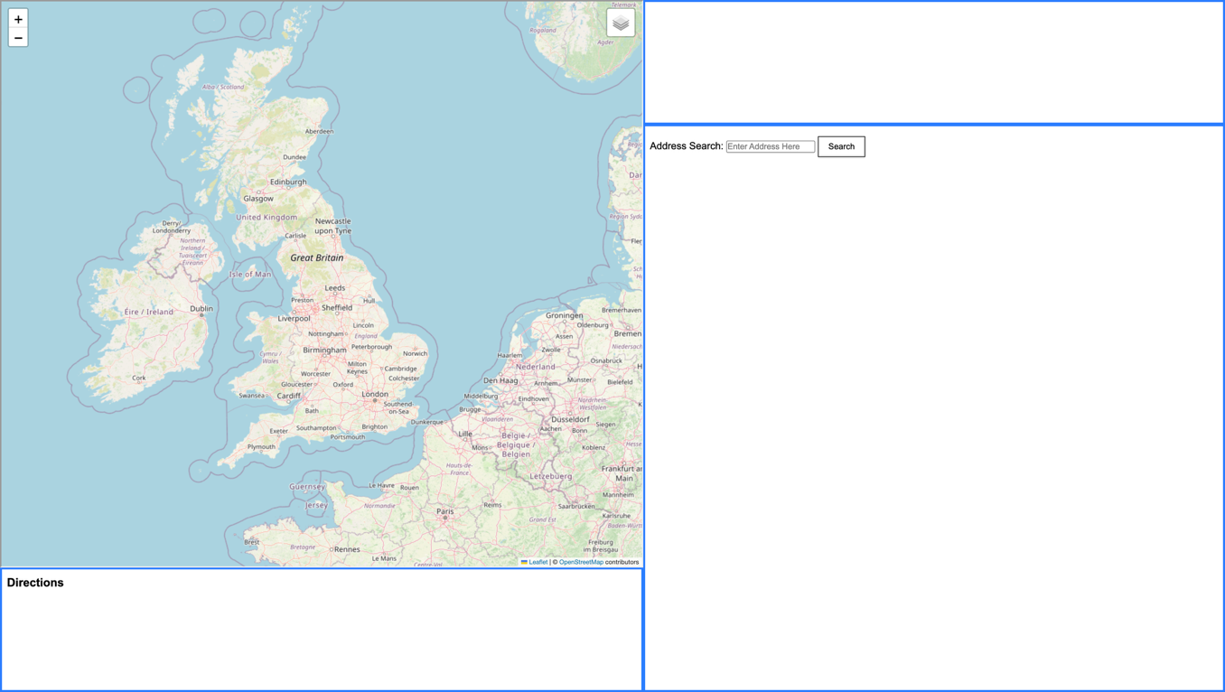

Searching
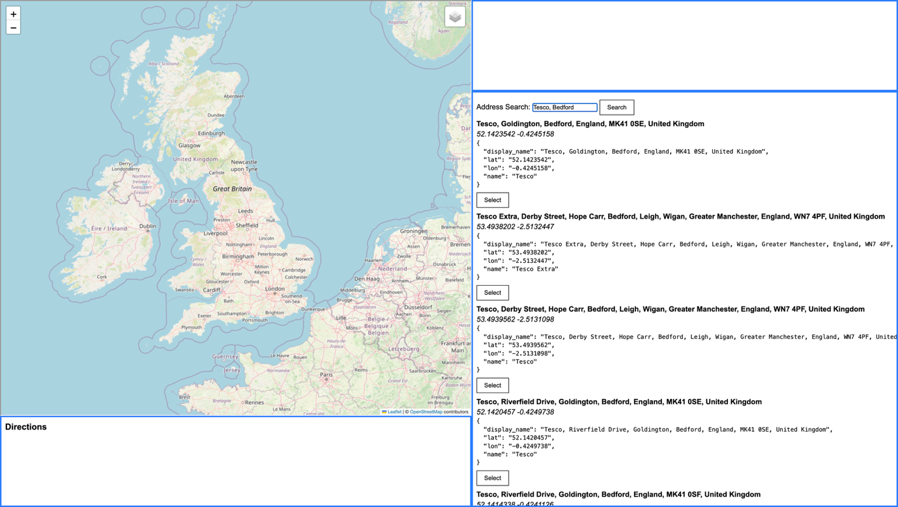

With Start Selected
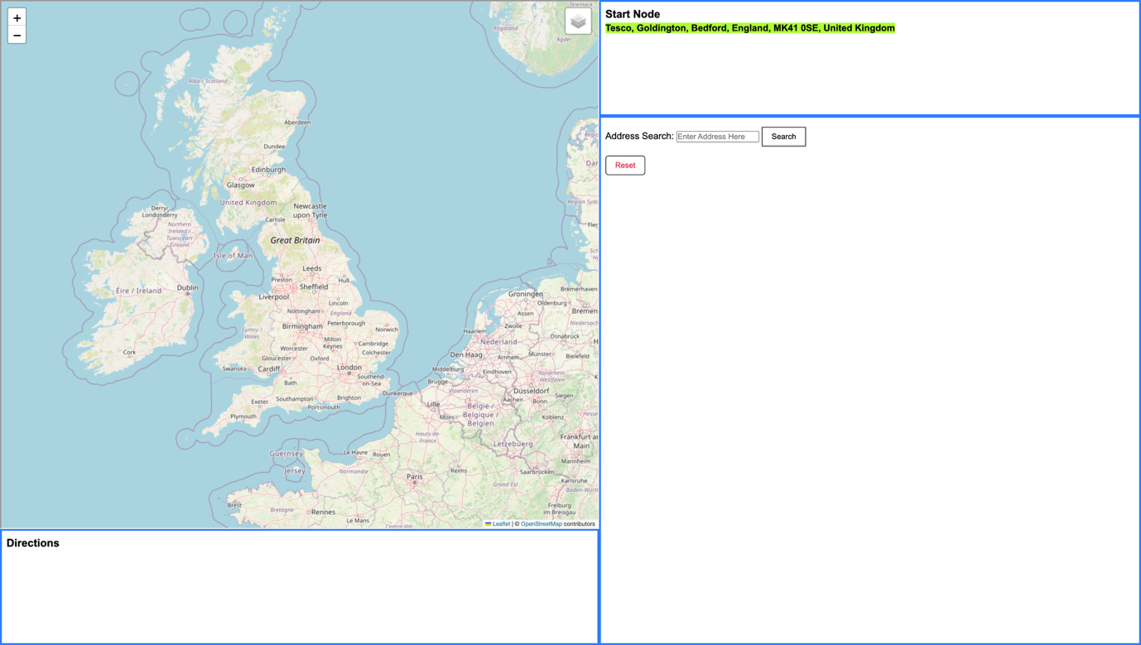

With Start/End Selected
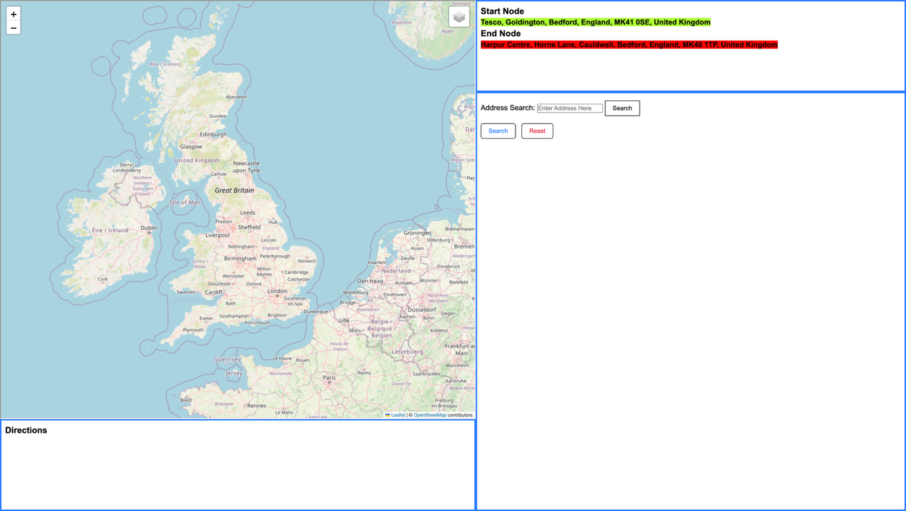

Awaiting Route from Back-End


Final Screen
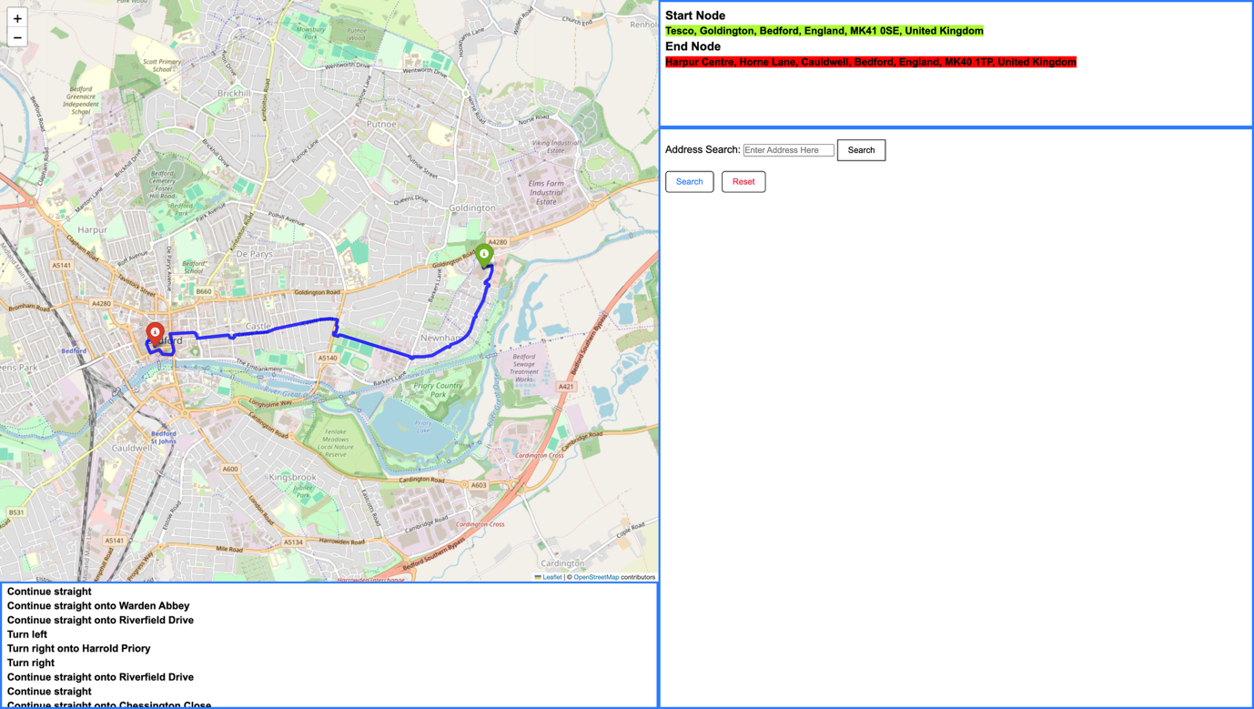

Techniques Used
Algorithm | Description | Page Ref
A* Algorithm | Algorithm used for generating the route | Pg 25
Recursive Backtracking | Reconstructing the path through the came_from list | Pg 30-31
OOP Programming | Storing Nodes as objects | Pg 23
Tree Traversal | Linking Nodes objects to other objects | Pg 23, Pg 25
Heuristic Search | Motorway prioritisation in heuristics() | Pg 30-31
Graph Traversal | Exploring nodes and edges | Pg 25
List & Dictionary Structures | Storing nodes, neighbours, and edge attributes | Pg 23, Pg 25, Pg 32, Pg 35
File/Database Reading | Reading OpenStreetMap Database data via SQLite/Pandas | Pg 32, Pg 36

Testing

Tests
NUMBER | DESCRIPTION | RESULTS | PASS
1.1,  1.1.1, | Create a user interface that allows users to input start and destination points, while keeping it simple and easy to navigate | I entered test data cases, inputting two random destinations into the search form. As of a result, the interface correctly allows me to select, and store start nodes and destination nodes for route calculations.  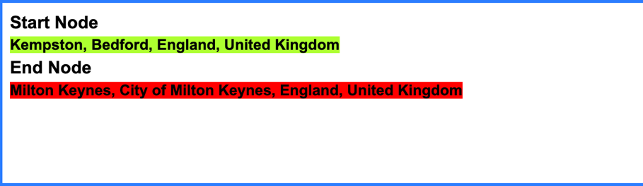
1.1.2,  1.1.3  1.1.4 | Ensure data validation, geocoding and user guidance if routes inputted are incorrect or invalid using Nominatim API | From the test data inputted prior, I decided to setup some console logs for each stage that test whether data is being validated.  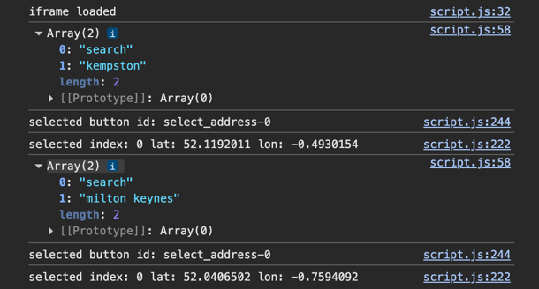  From this, I can identify that the search queries are correctly parsed and the API does geocode this textual data into latitudinal and longitudinal data.  Furthermore, when entering a scrambled string of letters, an error is returned guiding the user to check over their input  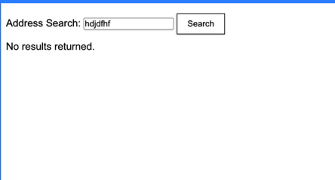  I have also tested the autocomplete feature, which works within my time constraints and provides 5 options for the user. This makes the interface more intuitive and easier to select nodes as locations don’t have to be defined exactly  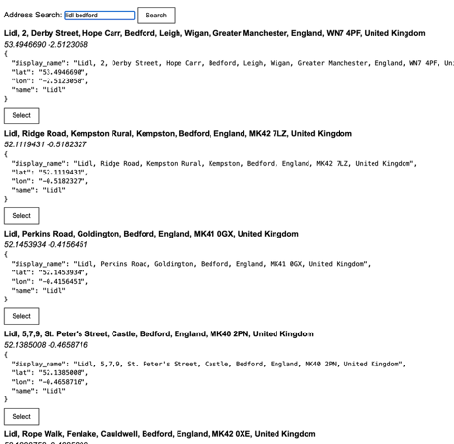
1.2,  1.2.1,  1.2.2,  1.2.3, | Implement an interactive map utilising OSM that displays the calculated route as well as highlighting major roads with colour coding for better readability. | When a route is generated, this is overlayed onto the OSM Basemap in a clear deep blue to ensure clarity.  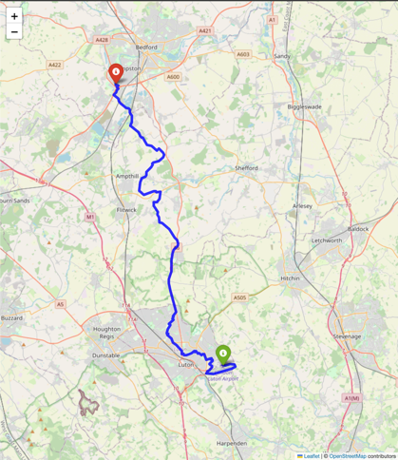  Furthermore, this interactive map also allows for zoom and pan functions, which allows for a clearer look at the pathways  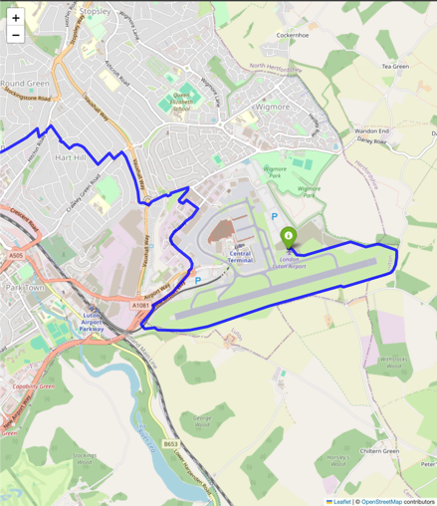
1.3,  1.3.1,  1.3.2 | Show turn-by-turn directions in a readable format, including road names for extra clarity | When a route is generated, scrollable directions are also generated and loaded into the user interface. This identifies all major road changes, turns and is helpful for further guiding the user in their journey.  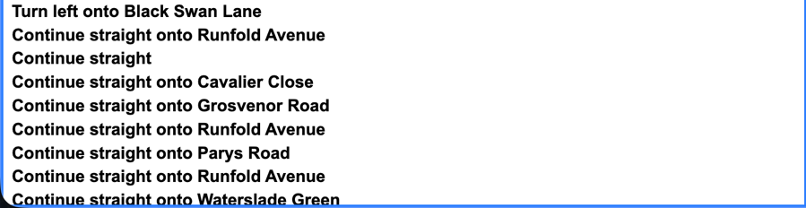
2.1,  2.1.1,  2.1.2,  2.1.3  2.1.4 | Ensure Full Route Calculation is completed in under 3 seconds  Use Heuristics to reduce the number of explored nodes  Implement A* Algorithm  Apply weighting to prioritize main roads. | 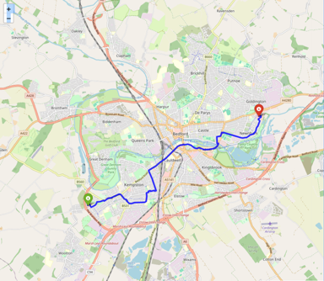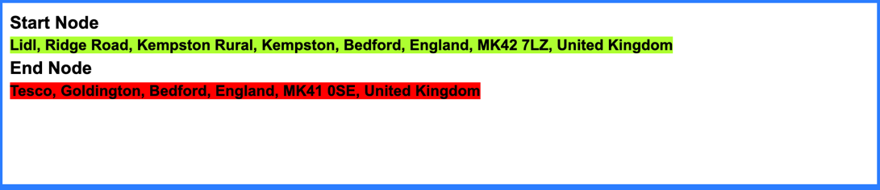  I have selected two nodes in order to test the efficiency of the Node. I have decided to calculate the route between two supermarkets on two separate sides of the town. From my objectives, my aim is for the algorithm to be under 5 seconds for nodes under 5km apart, however I have decided to test out a greater distance to test the algorithm beyond my expectations.  I have included a BFS Search Algorithm in order to ensure that a route is actually able to be found, and I have also taken timestamps at the beginning and end of data parsing and the algorithm being run. From my testing, the algorithm has worked within my expectations, calculating everything in under 3 seconds.
2.2.2  2.2.4 | Store Only Nodes and Ways relevant to routing to keep database under 200MB  Use Parallel processing for node creation and neighbour assignment |   As seen here, after preprocessing of OSM Data, and filtering unecessary information and nodes, I have managed to condense the Map Data into less than 200MB, with my current file being close to 5% of my limit set  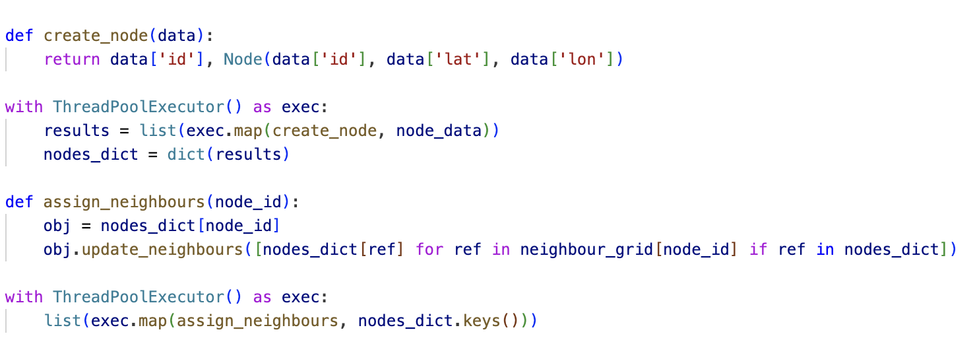  As seen in this code, I have implemented parallel processing for node creation and neighbour assignment. By doing so, I have been able to exponentially reduce the time needed for data initialisation, with times dropping from multiple minutes to less than a second.
 | Comparison of my Algorithm to Industry Standard Navigation Software | 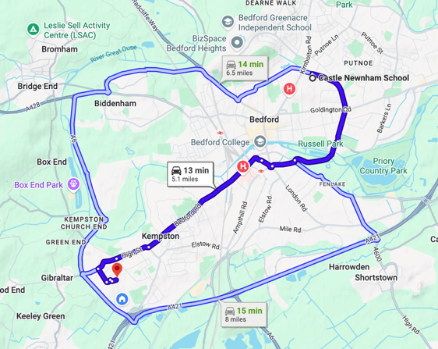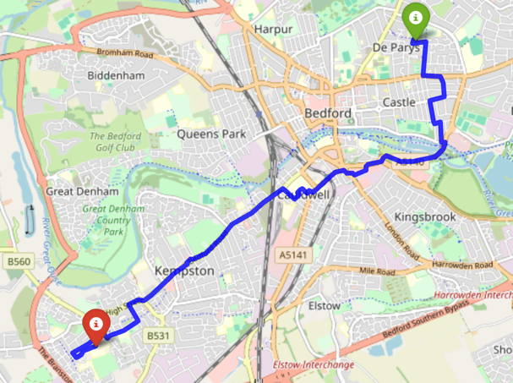  In a comparison with Google Maps, My algorithm has been able to calculate a route with high accuracy to Google Maps. Visually my algorithm has been able to keep an estimated 70% accuracy to Google Maps, which I am content with. Given my time constraints, My algorithm is demonstrating clear ability to generate an efficient route. With more time developing heuristics, I believe I can make this algorithm even more efficient.
 | Boundary Test Case | In order to test the algorithm at its absolute limit, I will undergo a route that will traverse along the entirety of the map data I have. In this case, I have the entirety of Bedfordshire loaded into my algorithm.  TEST 1  I have chosen Milton Ernest and Slip End as my two locations to generate a route from. These points are both extremely far from each other and serve perfect to see how my algorithm handles a large amount of data  Data Parsing is still remaining under 3 seconds and a valid route has been found. This is working extremely efficiently and I am happy with the outcome  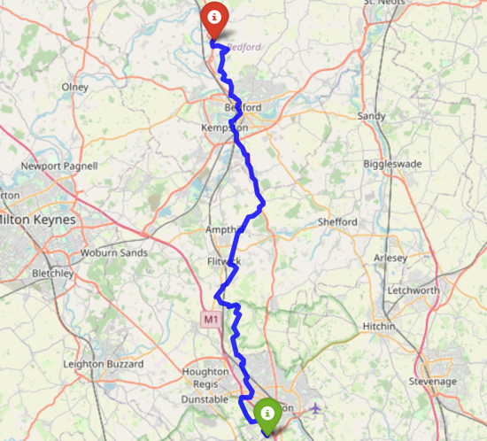
I will test the boundary of my data by selecting a node that I do not have in my dataset, so I can see how my code handles this issue.
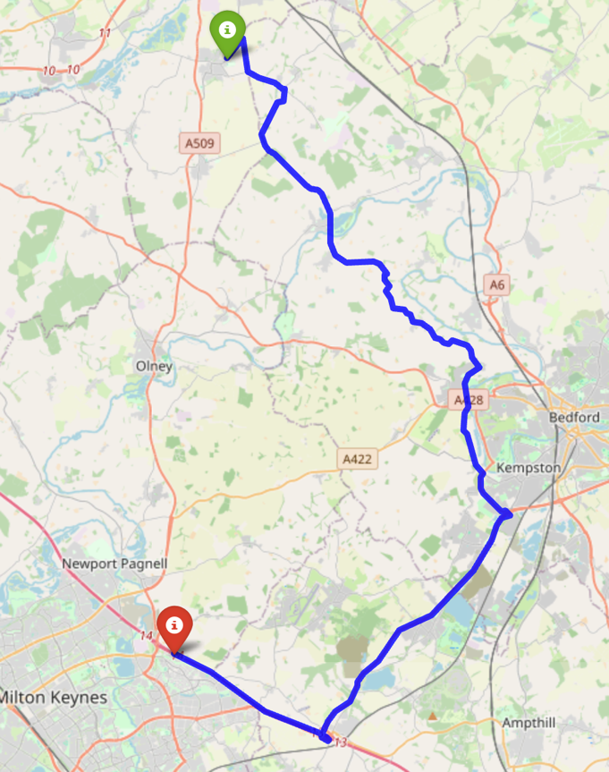
I have chosen a route between Milton Keynes and Daventry in Northamptonshire. My dataset only includes data from within Bedfordshire, and because of this, my route generated is incomplete. Currently, My algorithm is still working within its given instructions to convert the destination into the closest possible node, however in this case that is on the very edge of my data, and nowhere near the intended point. What I would hope for the outcome to be is to result in an error of no route being found, however this functionality has not been implemented. While this is an error in operation, I believe this is only minor and easily solveable, as the main issue lies within the lack of data provided in the system. In a real deployment, I will include all data of the entirety of the United Kingdom, which will prevent this from occuring.

Objectives Met

Main Objectives
Objective | How was it met?
1.1 | User Interface provides a form for inputting start and destination points
1.1.1 | The front end is very simple and displays clear progression from the user’s inputs
1.1.2 | When data is sent from the user to the server, it undergoes checks to ensure it is valid, and computes it into its latitude and longitude equivalent for the route to be calculated
1.1.3 | Returns a ‘no results returned’ error to the user if the address inputted is incorrect
1.2 | An interactive map is displayed on the front end, and the route is overlayed once generated
1.2.1 | A basemap created and distributed by OpenStreetMap is utilised to ensure that the route is clearer, as it highlights any roads nearby as well, not just the route
1.2.2 | Major roads are color-coded by default from the basemap
1.3  1.3.1 | Textual directions are generated alongside the route and displayed below it in a scrollable format
2.1 | Route is generated server-side and displayed for the user on their chosen client
2.1.1  2.1.2  2.1.3  2.1.4 | Optimised searching within the algorithm as well as creating a heuristic approach to make the algorithm work more efficiently
2.2.1 | Database is only accessed when it is necessary, otherwise data is stored locally. Thread safety has been ensured by only allowing threads to access local data rather than direct from database.
3.3  3.3.1  3.3.2 | Data stored in the database is relevant; the OpenStreetMap database has been filtered down to only store driveable routes.
2.1.3 | The algorithm only takes nodes from the database that it needs to compute a route, rather than processing the entire database at a time.
3.1  3.1.1  3.1.2  3.1.3 | My database has been designed to my specification, having a nodes table with Node ID, Latitude and Longitude, and a ways table with an ID field, list of Node ID’s on the same road, the type of road it is, and its speed.
3.2.1  3.2.2  3.2.3 | Within Preprocessing, data is filtered and organised to ensure that there are no duplicate entries and all data within the database is relevant for vehicular navigation

Stretch Objectives
Objective | How was it met?
1.1.4 | When the user inputs information, the Nominatim API autocompletes based on the information given, and returns potential routes.
1.2.3 | The folium library that generates the map provides an interactive map rather than a static, allowing the user to zoom in/out, and move it’s position
1.3.2 | Road names are taken from the database and included in the textual directions to provide further clarity
2.1.4 | Added a precedence to the road types within the algorithm, which applies a factor to its score, with a lower factor being better and a higher factor being worse
2.2.4 | Within my Data Initialisation, Parallel Processing is utilised by the way of threads, helping reduce the time to initialise data by over 100x, from multiple minutes to less than a second
2.3  2.3.1  2.3.2  2.3.4  3.4.3 | incomplete

Conclusion
Due to the time constraints, I made an educated decision to abandon the idea of integrating live traffic data. For how I plan to implement this, I would need a separate server running which caches traffic information in real-time, with this running alongside my actual application. Furthermore, I would need to develop a custom API to allow for data to progress to other files or dynamically update the database on a regular basis. Dynamically updating the database could also cause issues, especially with the same record being accessed/modified twice. This could cause mismatches with data and potential corruption/duplication issues. Then to circumvent this, I would need to develop a dedicated Database Management Server (DBMS) to manage all requests to the database. While this stretch task is doable, given the time I have to develop this, and the additional steps required to ensure this runs correctly, it is a smarter decision to avoid this entirely. Therefore, Stretch Objective 2.3 and 3.4.3 is incomplete.

User Feedback

Questionnaire
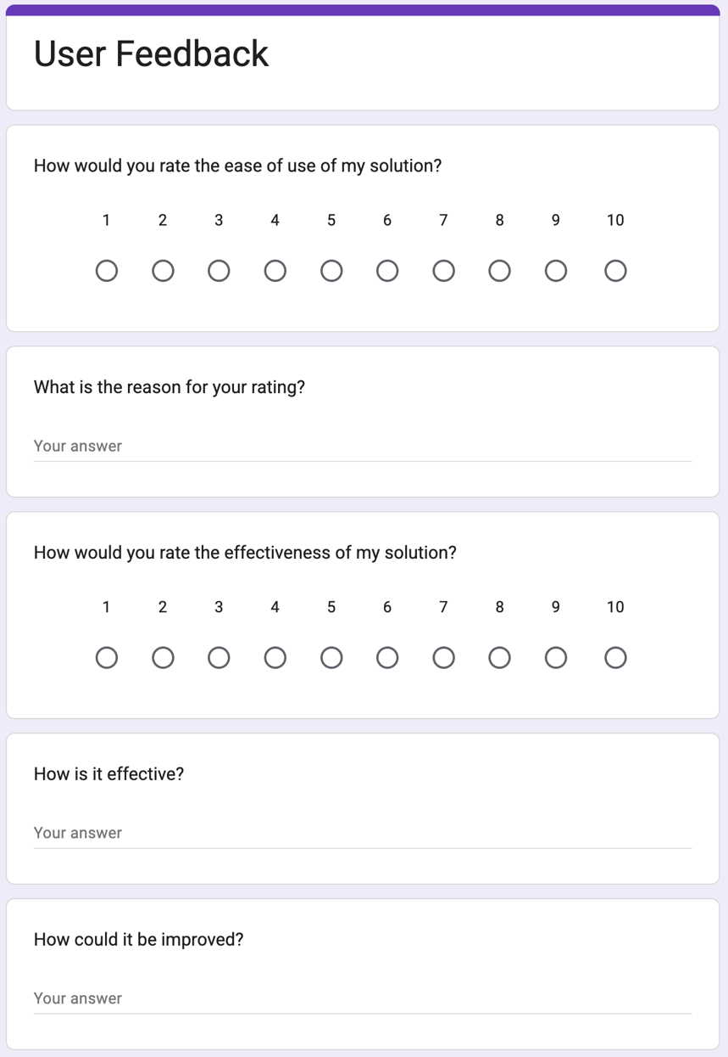

Results
Occupation | A-Level Student
Ease of Use | 8/10 – Very clear with how to progress through the app, however, does appear a blocky
Effectiveness | 10/10 – Does what it says it does, it has good performance and is overall very useful
Improvements | Make the interface less blocky, add more colours as it feels a bit outdated.

Occupation | Unemployed
Ease of Use | 9/10 – I like how everything is displayed, everything is kept on the same page and I don’t have to search around for any specific information
Effectiveness | 7/10 – It does generate a route, however it sometimes goes off track and takes random detours.
Improvements | Make the route more accurate

Occupation | A-Level Teacher
Ease of Use | 6/10 – I like how straightforward the layout is, it makes it so intuitive to use and requires little to no effort to navigate.
Effectiveness | 8/10 – It does create a route for driving, however this would not be useful to me personally, as I walk to work.
Improvements | Add navigation capabilities for people walking.

Improvements
My questionnaire has highlighted a few key areas that I can look at to further improve my solution.

Interface
I have received many comments about how easy the interface is to navigate, but one key area is that it ‘feels a bit outdated’. Due to the importance of my algorithm, I wasn’t able to spend a lot of time on the front-end design aspect of my solution, and rather focused on efficiency. I can see how the interface may need a refresh, as it contains lots of blank whitespace that remains unfilled and it is very plain. Next time, I will utilise more of the space, making it less empty, and incorporating more design styles, colours, and fonts. This will improve my interface by making it look more modern.

Route
I have attempted to optimise my route as well as possible given my time constraints, however there are definitely some areas in which I can improve my heuristic logic. I only focused on keeping the route on faster roads; however, I could’ve included logic to try and keep the route on the same roads and minimize turnings. I have optimised my algorithm as efficiently as I could, however I would want to spend more time on this if I were to return to this solution.

Route Capabilities
I have received a comment about how my solution is limited to what routes it can generate; however, this is something that I have been intentional with in my design. My solution is solely focused on finding routes for people in vehicular transport, aiming to improve travel times and help with logistics for businesses. I understand why people may want to have access to routes for other modes of transport, however people walking was not my intended demographic, so I am content with my route capabilities.

https://en.wikipedia.org/wiki/Google_Maps
https://en.wikipedia.org/wiki/Apple_Maps
https://support.apple.com/en-gb/guide/iphone/iphbaf51b2c0/ios
https://en.wikipedia.org/wiki/Waze
https://developer.tomtom.com/blog/build-different/add-live-traffic-data-your-site-5-minutes/
https://www.here.com/docs/bundle/traffic-api-developer-guide-v7

